Atomic Structure

- Atoms are made of _____________________________, _________________________, and __________________.
- ______________________ have a positive charge and are located in the ____________________of the atom.
- ______________________ have a negative charge and are located in the ____________________of the atom.
- ______________________ have a neutral charge and are located in the ____________________of the atom.
- Fill in the table below
Element | Atomic Number | Atomic Mass | # of Protons | # of Electrons | #of Neutrons | Metal, nonmetal, or metalloid
He

S

Sr

Cu

Atom Drawings- Bohr Model of an Atom
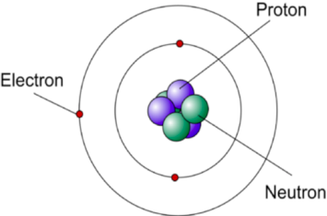
Electrons circle around the nucleus in orbits or electron shells.

6. Draw the Bohr model of Beryllium

- Draw the Bohr model of Phosphorous.

- Draw the Bohr Model of Nitrogen

Isotopes
- Using the picture below, What is the difference between Carbon and Carbon-14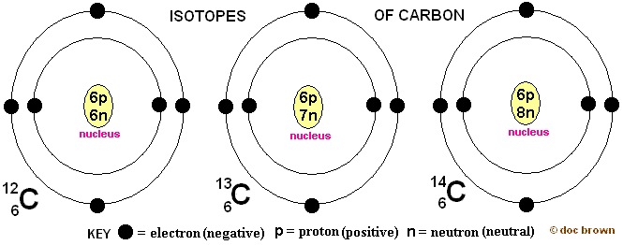

- Carbon-14 is an isotope of carbon. What is an isotope? (look at number 9)

- Draw Oxygen-16 and Oxygen-18. Which one of these are an isotope and why?

