Name : ________________________________ Hour: ______



**Lab #12: Measuring Calories**

**Part 1: Pre-Lab**

*Annotate the following information*



What does it mean to say that we burn food in our bodies? The digestion and metabolism of food converts the chemical constituents of food to carbon dioxide and water. This is the same overall reaction that occurs when organic molecules such as carbohydrates, proteins, and fats are burned with fire in the presence of oxygen. The reaction of an organic compound with oxygen to produce carbon dioxide, water, and heat is called a *combustion reaction.* The chemical equation for the most important reaction in our metabolism, the combustion of glucose, is shown in Equation 1.

C6H12O6 + O2 🡪 H2O + CO2 + heat

Within our bodies, the energy released by the combustion of food molecules is converted to heat energy (to maintain our constant body temperature), mechanical energy (to move our muscles), and electrical energy (for nerve transmission). This energy is refered to as *calorie content (note the lowercase c).* Nutritional Calories (note the uppercase C) are what we read on a nutrition label and are equal to 1000 calories. This gives us a new conversion factor.

**1000cal = 1Cal**

One calorie is defined as the amount of heat required to raise the temperature of 1 gram of water by 1°C. (This is also the definition of the specific heat of water.) Nutritionists and food scientists measure the calorie content of food by burning the food in a calorimeter surrounded by water and taking measurements of the water to calculate energy. Since energy cannot be created or destroyed the amount of energy the water absorbs or loses is directly proportional to the energy lost or absorbed by the food being burned. In order to calculate the amount of caloric energy we need to use a new specific heat value for water. This value is **1 cal/gOC.**

**Pre-Lab Questions:**

1. Convert 500 calories into nutritional Calories using your new conversion factor.
2. What is the specific heat of water using the unit for calories instead of joules?
3. Balance the following equation

C6H12O6 + O2 🡪 CO2 + H2O

1. If heat is on the product side of the reaction is the reaction endothermic or exothermic?
2. What type of reaction is the digestion of food? Describe this type of reactions.

**Pre-Lab Continued: Practice Lab Calculations**

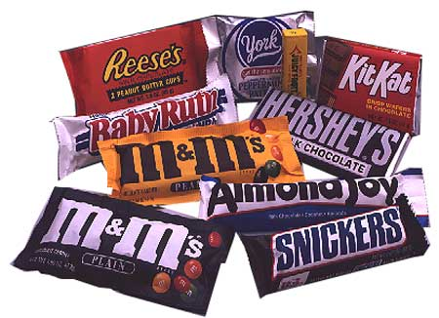

You want to find the Calories in a candy bar that has a serving size of 70g. In a calorimetry experiment a 2.0-g sample of this candy bar was burned in a calorimeter surrounded by 1000g of water. The temperature of the water in contact with the burning candy bar was measured and found to increase from an initial temperature of 21.2 OC to a final temperature of 24.3 OC.

1. Calculate the amount of heat in *calories* released when the sample burned. Use the amount of water that was heated and the specific heat of water in *calories* is 1 cal/g°C.



1. Convert the heat in calories to nutritional Calories. 1000cal = 1Cal
2. To obtain the *energy content* (also called fuel value) in units of Calories per gram, divide by the mass of the burned sample in grams.
3. Multiply the previous answer by the total number of grams in the candy bar to calculate the total *Calorie content* of the entire candy bar in Calories.

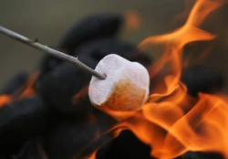

**Part 3: Procedure for *“*Soda-Can” *Calorimeter***



1. Place a food sample on the food holder. Measure and record the combined mass of the food holder and sample. Place the food holder on a ring stand.
2. Obtain a clean empty soda can and zero out the balance.
3. Add about 50 mL of tap water to the can and measure the mass of the water.
4. Bend the top tab on the can up and slide a stirring rod through the hole. Suspend the can on a ring stand using a metal ring. Adjust the height of the can so that it is about 2.5 cm above the food holder.
5. Insert a thermometer into the can. Measure and record the initial temperature of the water.
6. Light the food sample at the bottom and center it under the soda can. Allow the flame to heat the bottom of the can until the food sample stops burning. Record the maximum (final) temperature of the water in the can.
7. Measure and record the final mass of the food holder and sample.
8. Clean the bottom of the can and remove any food residue from the food holder. Repeat the procedure with a second food sample.

**Part 4: Data Collection of Calorimeter**

**Data Table 1: Calorimeter**

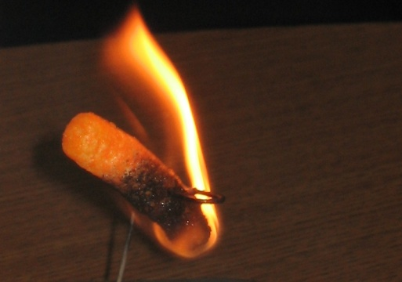

|  |  |  |  |  |  |  |  |
| --- | --- | --- | --- | --- | --- | --- | --- |
| **Food Sample** | **Initial Mass with holder** | **Final Mass with holder** | **Δm, mf-mi** | **Mass of water in can** | **Initial temperature of water** | **Final temperature of water** | **ΔT, Tf-Ti** |
| Cheeto |  |  |  |  |  |  |  |
| Cheeto |  |  |  |  |  |  |  |

**Part 5: Calculations**



1. Use the heat equation to calculate the heat absorbed by the water in the calorimeter for **each** food sample. Use the mass of the water heated and the specific heat of water in calories. Your results should be reported in *calories.*
2. Convert your answers from calories to nutritional Calories. 1000cal = 1Cal
3. Use the results from Question #2 and the change in mass, Δm, to calculate the energy content (fuel value) of the food sample in units of *Nutritional* *Calories per gram* (Hint: Cal/g is your calculation).
4. Get results for question 3 from 2 other groups and calculate the average of the 3 below.

**Data Table 2: Class Average**

|  |  |  |  |  |
| --- | --- | --- | --- | --- |
| Food Sample | Cal/g | Cal/g | Cal/g | Average Cal/g |
|  |  |  |  |  |

1. Now let’s calculate the “real” energy based on the serving size on the nutrition label as shown below. Find and convert the appropriate units to calculate energy content (Cal/g).

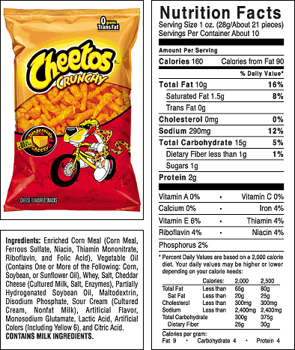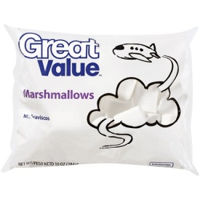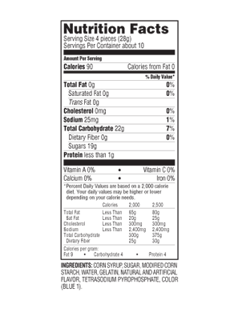

**Data Table 3: Nutritional Facts**

|  |  |  |  |
| --- | --- | --- | --- |
| Food Sample | Calories | Serving Size in grams | Cal/g |
|  |  |  |  |
|  |  |  |  |

**Part 6: Post Lab Questions**

1. Rank the snack foods in order of their average energy content, from highest to lowest. Which snack food has the highest energy content? The lowest? Why do you think this is?
2. How do your experimental average Cal/g in data table 2 compare to what it really is in data table 3?
3. Find your percent error for each snack using the following equation. Experimental is what you got from lab. Theoretical is what you should have got and is from the nutrition label.

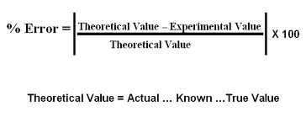

1. Based on your error consider the major sources of error in this experiment. Do you think your results are off on the high side or the low side? Explain.
2. Based on your knowledge of the fat content in different snack foods do you think a high-fat or a low-fat snack would have more relative energy content and why?
3. Look up the nutrition labels for 2 of your favorite snacks/drinks and calculate the energy content in Cal/g. Does this surprise you!? Why or why not?