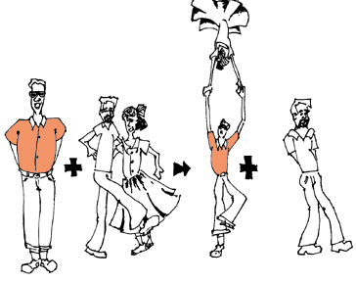
Classifying Chemical Reactions
Part 1 Pre-Lab:
Materials
- Labmaster
- Temperature Probe
- Balance
- Mg Ribbon, HCl, (NH₄)₂CO₃, CaCO₃, CuCl₂, Zn, Na₃PO₄, NaOH

*Annotate the following information*
A chemical reaction is defined as any process in which one or more substances are converted into new substances with different properties. Chemical reactions change the identity of the reacting substance(s) and produce new substances. Observing the properties of the reactants and products is therefore a key step in identifying chemical reactions. Some of the observations that may be associated with a chemical reaction include: (1.) Release of a gas, (2.) Formation of a precipitate, (3.) Color changes, (4.) Temperature changes, (5.) Emission or absorption of light.
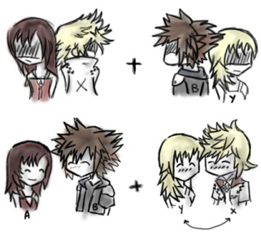
The power of chemical reactions to transform our lives is visible all around us and even in our bodies. Chemists try to make sense of the great variety of chemical reactions the same way that biologists organize their knowledge of life, by sorting information into groups and classifying it. The purpose of this experiment is to observe a variety of chemical reactions and to identify patterns in the conversion of reactants into products. The observations of these reactions will be analyzed to classify the chemical reactions into different groups and predict products.
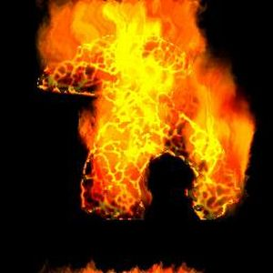
Pre-Lab Questions
- According to the reading, how do you know a chemical reaction has occurred?

- Chemical reactions are written using reactants and products. The following is a description of a chemical reaction. Write the reaction as an equation and then balance it.
''When solid sodium bicarbonate (NaHCO₃), is heated in a test tube, carbon dioxide (CO₂) is released into the surrounding air and water (H₂O) condenses at the mouth of the test tube. Some sodium carbonate (Na₂CO₃) remains behind in the test tube."

- Common observations of a chemical reaction are all around us. Name a common or everyday occurrence that involves a type of chemical reaction. Try at least 3 examples.
Example: When a candle bums, it gives off light and heat. The emission of light and heat is evidence for a chemical reaction.
(1.)

(2.)

(3.)
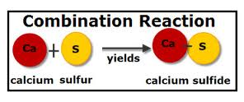
- What is the purpose of this lab?

Chemical reactions may be classified by considering the number, physical/chemical properties, and arrangement of reactants and products in a reaction. (See Table 1).
Table 1
Type of Reaction | General Description & Example
Combustion | A combustion reaction is when oxygen combines with another compound to form water and carbon dioxide. These reactions are exothermic, meaning they produce heat. An example of this kind of reaction is the burning of napthalene:  C₁₀H₈ + 12 O₂ ---> 10 CO₂ + 4 H₂O  Notes:
Synthesis/ Combination | A synthesis reaction is when two or more simple compounds combine to form a more complicated one. These reactions come in the general form of:  A + B ---> AB  One example of a synthesis reaction is the combination of iron and sulfur to form iron (II) sulfide:  8 Fe + S₈ ---> 8 FeS  Notes:
Decomposition | A decomposition reaction is the opposite of a synthesis reaction - a complex molecule breaks down to make simpler ones. These reactions come in the general form:  AB ---> A + B  One example of a decomposition reaction is the electrolysis of water to make oxygen and hydrogen gas:  2 H₂O ---> 2 H₂ + O₂  Notes:
Single Replacement/  Displacement | This is when one element trades places with another element in a compound. These reactions come in the general form of:  A + BC ---> AC + B  One example of a single displacement reaction is when magnesium replaces hydrogen in water to make magnesium hydroxide and hydrogen gas:  Mg + 2 H₂O ---> Mg(OH)₂ + H₂  Notes:
Double Replacement/  Displacement | This is when the anions and cations of two different molecules switch places, forming two entirely different compounds. These reactions are in the general form:  AB + CD ---> AD + CB  One example of a double displacement reaction is the reaction of lead (II) nitrate with potassium iodide to form lead (II) iodide and potassium nitrate:  Pb(NO₃)₂ + 2 KI ---> PbI₂ + 2 KNO₃  Notes:

Part 2: Procedure (The more descriptive you are the better off you will be!)
For each reaction, record
- The color and appearance of the reactant(s),
- The evidence for a chemical reaction
- The properties of the product(s) in the data table.
Reaction #1
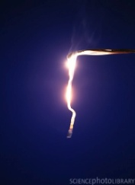
- Obtain a 3-4 cm strip of magnesium metal ribbon. Hold the piece of magnesium with forceps or crucible tongs and heat the metal in a laboratory burner flame. Caution: Do not look directly at the burning magnesium the ultraviolet light that is produced may damage your eyes.
- When the magnesium ignites, remove it from the flame and hold it over an evaporating dish or a Pyrex® watch glass until the metal has burned completely. Let the product fall into the evaporating dish.
- Turn off the laboratory burner and observe the properties of the product in the evaporating dish.
- Record observations in the Table 2.

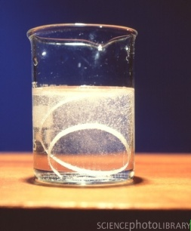
Reaction #2
- Using a pipet, add about 2 mL (40 drops) of 1 M hydrochloric acid (HCl) solution to a small test tube.
- Obtain a 2-3 cm strip of magnesium metal ribbon and coil it loosely into a small ball. Add the magnesium metal (Mg) to the acid in the test tube.
- Carefully feel the sides of the test tube and observe the resulting chemical reaction for about 30 seconds.
- While the reaction is still occurring, light a wood splint and quickly place the burning splint in the mouth of the test tube. Do not put the burning splint into the acid solution.
- Record observations in the Table 2.

Reaction #3
- Place a small amount (about the size of a jelly bean) of calcium carbonate (CaCO₃) in a clean and dry test tube.
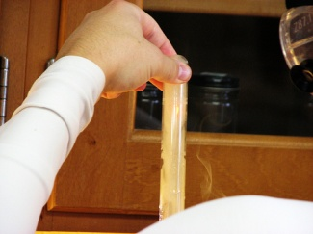
- Using a pipet, add about 1 mL (20 drops) of 1 M hydrochloric acid (HCl) to the test tube. Feel the sides of the test tube and observe the reaction for 30 seconds.
- Quickly light a wood splint and insert the burning splint about halfway down into the test tube. Do not allow the burning splint to contact the reaction mixture.
- Record observations in the Table 2.

Reactions #4
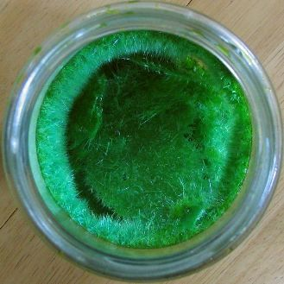
- Using a pipet, add about 2 mL (40 drops) of 0.5 M copper(II) chloride solution (CuCl₂) into a small test tube.
- Add 1-2 pieces of mossy zinc or one piece of zinc shot (Zn) to the test tube and observe the resulting chemical reaction.
- Record observations in the Table 2.

Reaction #5
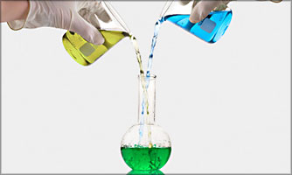
- Using a pipet, add about 2 mL (40 drops) of 0.5 M copper(II) chloride solution (CuCl₂) into a small test tube.
- Using a fresh pipet, add about 25 drops of 0.5 M sodium phosphate (Na₃PO₄) solution to the test tube.
- Record observations in the Table 2.

Reaction #6
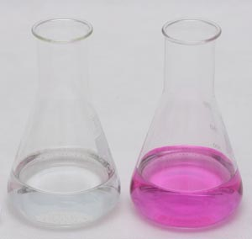
- Using a pipet, add 20 drops of 1 M sodium hydroxide solution (NaOH) into a small test tube.
- Add one drop of phenolphthalein indicator to the test tube and mix the solution by gently swirling the tube. Hint: Phenolphthalein is called an "acid-base" indicator.
- Using a clean pipet, add 1 M hydrochloric acid solution (HCl) one drop at a time to the test tube. Count the number of drops of acid required for a permanent color change to be observed.
- Record observations in the Table 2.

Table 2 Classifying Chemical Reactions
Rxn # | Color and Appearance of the Reactants | Evidence of a chemical reaction | What does the final product(s) look like?
1
2
3
4
5
6

Post-Lab Questions
- Balance each chemical equation for the reactions 1-8.
- Classify each reaction using the information provided in Table 1.
Classify reaction?
Reaction #1:
Mg (s) + O₂ (g)--> MgO (s)
Classify reaction?

Reaction #2:
Mg (s) + HCl (aq) --> MgCl₂ (aq) + H₂ (g)

Classify reaction?
Reaction #3
CaCO₃ (s) + HCl (aq) --> CaCl₂ (aq) + H₂O (l) + CO₂ (g)

Classify reaction?
Reaction #4:
Zn (s) + CuCl₂ (aq) --> Cu (s) + ZnCl₂ (aq)

Classify reaction?
Reaction #5:
CuCl₂ (aq) + Na₃PO₄ (aq) --> Cu₃(PO₄)₂ (s) + NaCl (aq)

Classify reaction?

Reaction #6:
HCl (aq) + NaOH (aq) --> NaCl (aq) + H₂O (l)

- Now we will do the reverse steps. Classifying chemical reactions helps chemists to predict the possible products that will form when two or more substances are mixed. The reactants for the following reactions are given to you. Using the information in Table 1, complete the following equations by predicting the products of each chemical reaction.

- Double replacement: NaOH (aq) + CuS0₄ (aq) --->

- Combination: Al (s) + 0₂ (g) --->

- Combustion: C₆H₁₂0₆ (s) + 0₂ (g) --->

- Decomposition: CaC0₃ (s) --->

(e) Single replacement: Fe(s) + Pb(NO₃)₂ (aq) --->

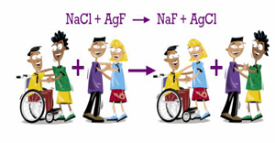

Classifying Chemical Reactions Practice Worksheet
How did you do??? Let’s try some more! Write a chemical equation for each reaction. Balance and classify each one.
- Copper metal heated with oxygen gives solid copper(II) oxide.
Combination: Cu + O₂ --->

- Mixing ammonium nitrate and sodium hydroxide solutions gives aqueous sodium nitrate, ammonia gas, and water.
Double Replacement: NH₄NO₃ + NaOH --->

- Mercury(II) nitrate solution reacts with potassium iodide solution to give a mercury(II) iodide precipitate and potassium nitrate solution.
Double Replacement: Hg(NO₃)₂ + KI --->

- Aluminum metal and sulfuric acid yield aqueous aluminum sulfate and hydrogen gas.
Single Replacement: Al + H₂SO₄ --->

- Acetic acid and lithium hydroxide solution produce water and aqueous lithium acetate.
Double Replacment: HC₂H₃O₂ + LiOH --->

- Sulfur dioxide gas reacts with oxygen on a platinum catalyst surface to produce sulfur trioxide gas.
Combinations: SO₂ + O₂ --->

- Sodium metal reacts with water to give sodium hydroxide solution and hydrogen gas.
Single Replacement: Na + H₂O --->

- Heating solid potassium chlorate in the presence of manganese dioxide catalyst produces potassium chloride and oxygen gas.
Decomposition: KClO₃ --->

