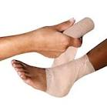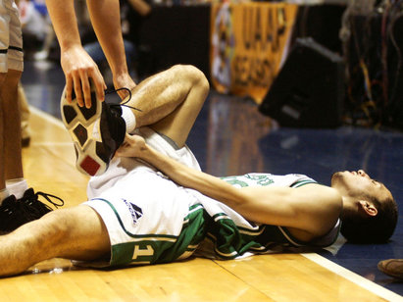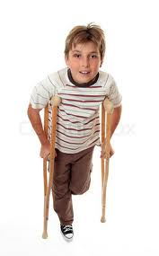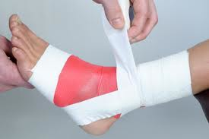FN99803-IMG02

Your favorite player just sprained his ankle. What can you tell him to get him back into playing shape?

Phase change

1. Think back to your energy equation. When calculating the amount of energy in a reaction, there are three variables to consider. What are those three variables?
2. Write an equation that shows how these three variables all play a part in calculating the total energy in a reaction.
3. According to the reading, how would you know that an endothermic reaction is occurring?

*If you were to sprain your ankle, a doctor would tell you to ice and elevate it. The ice that is placed on your ankle is an endothermic reaction. Endothermic Reactions occur when the reaction absorbs energy from the environment. Since the ice is absorbing energy from its environment, i.e. your ankle, then your ankle begins to feel cold.*

*Quick!*

Get me an ice pack!

You have sprained your ankle and don’t know what to do! Should you heat it? ice it? ouch!!

Unit 2

Think about this:

1. Infer from the reading, in which direction is the energy flowing? Is it flowing from your ankle to the ice pack or from the ice pack to your ankle?

**Part 1. Observing a Commercial Cold Pack**

Take your cold pack apart and separate the reactants from the packaging and place

them in 2 separate cups. DON’T FORGET TO ZERO THEM OUT!!

1. What is the mass of the reactants in your commercial coldpack?

Mass of Liquid: __________________grams

Mass of Solid: __________________grams

1. After the reactants are mixed, how much temperature change occurred?

Tinitial =

Tfinal =

ΔT =

1. The liquid is water and has a specific heat of 4.18 J/gOC. Calculate the amount of energy the water absorbed during the reaction.

Total Joules =

1. What is the energy for the reaction?
2. Determine how much energy is absorbed per gram of solid (Joules/gram of solid)

Joules/gram =

**Part 2: Creating a “Better” Cold Pack**

You have been hired by CVS to create a “better” cold pack. It seems that customers would like a smaller cold pack that can be easily stored in either a purse or glove compartment of a car. In addition, they would like the new cold pack to get “colder” than the competition.

CVS believes that this coldpack can be created through the reaction of Ammonia Nitrate and Water. Your job is to design a reaction that has less total mass than the mass of the competitors but creates a “colder” final product

**Prediction:**

Before beginning your experimentation, make a prediction as to how you may be able to design a coldpack that meets the design requirements described by CVS’s marketing department.

1. You have time to conduct at least two trials with the stock ammonia nitrate and water. Be sure to record the mass of each of the reactants and the temperature change for each trial. (Record all data in Table 1.)

DO NOT USE MORE THEN 20 grams of solid!!!

Now test it out! How can you make the best cold pack?? Show all data and work below. Remember…no more than 20g of each.

**Data Table 1:**

|  |  |  |  |  |  |  |
| --- | --- | --- | --- | --- | --- | --- |
| **Trial** | **Mass of Solid**  **g** | **Volume of Water**  **mL** | **Mass of Solution**  **g** | **Tinitial**  **oC** | **Tfinal**  **oC** | **Δ Temp**  **oC** |
| 1 |  |  |  |  |  |  |
| 2 |  |  |  |  |  |  |

1. Choose the best and coldest trial. Convert each reactant from grams to moles.

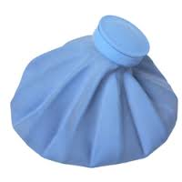Moles Water, H2O, in Final Reaction

Moles Ammonia Nitrate, NH4NO3, in Final Reaction

1. Calculate the amount of Joules from your coldest trial.
2. Convert your answer to #3 into Kilojoules. (HINT: 1kJ=1000J)
3. Using your answer from problem #2 and #4, calculate the amount of energy change in Kilojoules/mole of Solid Ammonia Nitrate

**Part 3: Calculations/Problems**

1. The research department at CVS states that their solution absorbs 25.7 KJ/mole.. How do your result compare?
2. Assuming that the value for this mixture is 25.7 KJ/mole, calculate the amount of heat absorbed from a cold pack that contains 185 grams of ammonia nitrate.

FN99803-IMG01Part 4: Explanation

Chemistry Class

Write a paragraph explaining what happened in this lab. You must use ALL the following terms: **System, Surroundings, flow of heat, exothermic, endothermic, energy, absorbing, and releasing.**