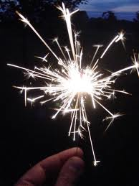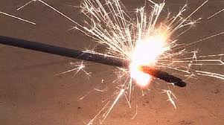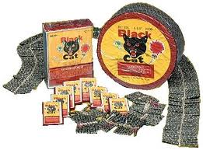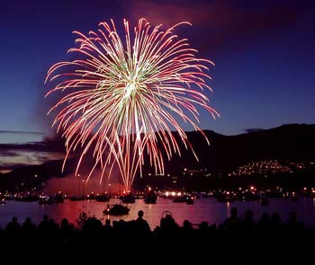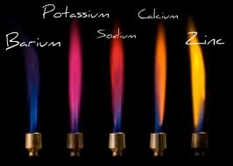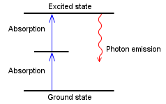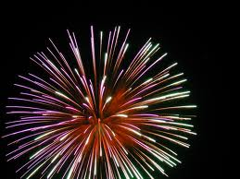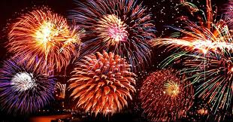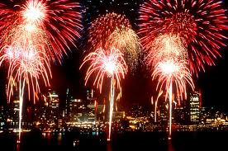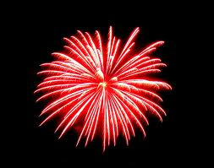

### Lab #17

* **Wavelength**
* **Frequency**
* **Energy**
* **Photon**
* **Ground state**
* **Excited state**
* **Energy Levels**
* **Wood splints soaked in CaCl2, CuCl2, LiCl, KCl, NaCl, SrCl2 and H2O**

**Have you ever been to an aerial fireworks show at an amusement park, baseball game, Fourth of July celebration, or on New Year's Eve and wondered about how all the impressive colors and sounds are produced? People everywhere enjoy the fantastic explosions and the brilliant light displays of fireworks. However, these spectacles are much more than just a form of entertainment. Each firework launched into the sky is a precisely formed assembly of chemicals and fuel, carefully calibrated to produce a particular effect**

# How does a pyrotechnician create such a beautiful display of fireworks?

**Part 1:**

**Pre-Lab Questions:**

1. **Skim through the procedure. Are these flame tests quantitative or qualitative? How do you know?**
2. **What do you think produces the different colors in fireworks?**

Chemistry of Fireworks

chemical reactions in

# Flame Test

##### Materials

##### Key Words:

##### Key words:

#### Save the Date!

### The

## Fill in the Blank:

**An electron may drop all the way back down to the ground state in a single step, emitting a photon in the process. Alternatively, an electron may drop back down to the ground state in a series of smaller steps, emitting a photon with each step. The energy of the emitted photon determines the color of light observed in the flame.**

## How to Make Color!

1. **Fill in the blanks: when an atom absorbs energy, the electrons move from their _______________ state to a(n) _______________ state. When an atom emits energy, the electrons move from a(n) _______________ state to their _______________ state and give off a _______________.**

**When a substance is heated in a flame, the atoms absorb energy from the flame. This absorbed energy allows the electrons to be promoted to excited energy levels. From these excited energy levels, there is a natural tendency for the electrons to make a transition or drop back down to the ground state. When an electron makes a transition from a higher energy level to a lower energy level, a particle of light called a photon is emitted.**

## The Excited Atom!

**Just as a fingerprint is unique to each person, the color of light emitted by an element heated in a flame is also unique to each element. In this experiment, the characteristic color of light emitted by calcium, copper lithium, potassium, sodium and strontium will be observed.**

## Unique Colors

###### Back ground Information:

# The Flame Test

# Every Color has a wavelength!

1. **Fully extinguish the wooden splints by immersing them in a beaker of water before discarding them in the trash to avoid trashcan fires.**
2. **Wear goggles!**
3. **Record the salt that you are looking at in the data table.**
4. **Light the Bunsen burner at your station.**
5. **Dip the soaked end of one of the wooden splints in the flame. Observe the color of the flame. Allow the splint to burn until the color fades.**
6. **Extinguish the splint in the provided beaker of water.**
7. **Record your observations for the flame color produced by the molecule in the data table.**
8. **Rotate to the next station and repeat steps 1-5.**

|  |  |  |
| --- | --- | --- |
| **Molecule** | **Color of Flame** | **Wavelength Range** |
|  |  |  |
|  |  |  |
|  |  |  |
|  |  |  |
|  |  |  |
|  |  |  |
|  |  |  |
|  |  |  |

* **Violet:   400 - 420 nm**
* **Indigo:   420 - 440 nm**
* **Blue:   440 - 490 nm**
* **Green:   490 - 570 nm**
* **Yellow:  570 - 585 nm**
* **Orange: 585 - 620 nm**
* **Red:   620 - 780 nm**

###### Using the list provided, rewrite the appropriate wavelength corresponding to each color.

|  |  |
| --- | --- |
| **Molecule** | **Color of Flame** |
|  |  |
|  |  |
|  |  |
|  |  |
|  |  |
|  |  |
|  |  |
|  |  |

# Part 3: Procedure

1. **A glass rod was heated in a burner flame and gave off a red flame. Based on the color, what metal may be in the glass rod?**
2. **The flame tests that we did today were mostly qualitative. Write a short procedure, thinking about experiments we have recently done, of a quantitative version of this lab.**
3. **The alkali metals cesium (Cs) and rubidium (Rb) were discovered based on their characteristic flame colors.** 
   1. **Cesium is named after the sky. What color of light does this metal gives off when heated?**
   2. **Rubidium is named after a Rubyy. What color of light does this metal give off when heated?**
   3. **Many street lights produce an orange-ish glow. What element is predominantly found in the street lights that line our roads?**
4. **Think about a flame burning at a bonfire. What do you know about the heat released from a red flame versus a blue flame? Which one releases more energy?**
5. **Using the data table on page 3, what is the difference between the wavelength of a wave that produces a red color versus a blue color? Frequency is the number of wave cycles that travel past a fixed point per unit of time. What do you think the frequency of a blue flame is compared to a red flame? Which one is faster?**
6. **Why was one of the wood splints soaked only in water?**
7. **In this lab the electrons in each element gained energy and then released that energy. Where did this energy come from?**
8. **When the electrons emitted energy, how could we tell?**

# Consider This:

Spring 2012

THe Lorem Ipsums

The Lorem Ipsums

**Error! Reference source not found.**  
**Error! Reference source not found.**, **Error! Reference source not found.Error! Reference source not found.**

[Recipient]