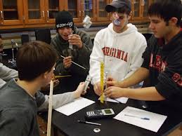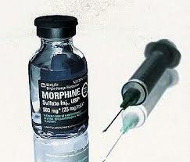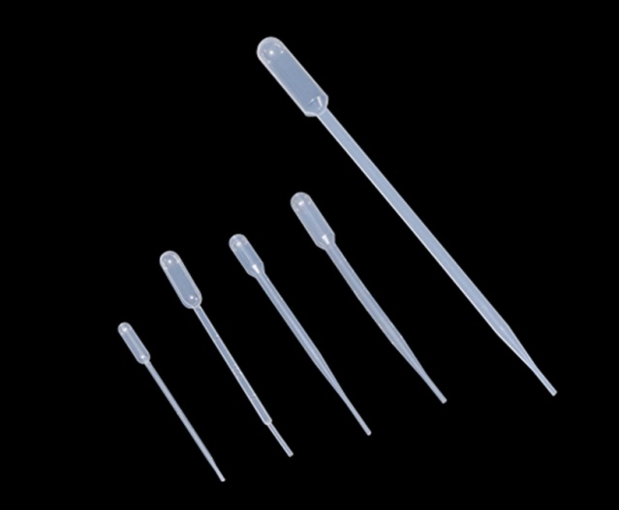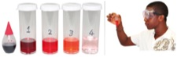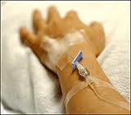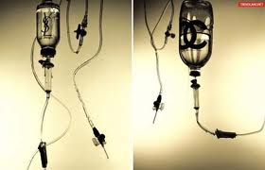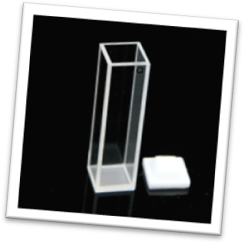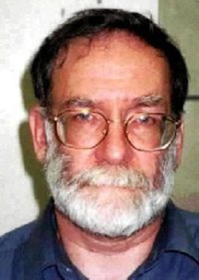

Harold Frederick Shipman was born in Nottingham, England as the second of four children. Shipman was particularly close to his mother, who died of lung cancerwhen he was 17. Due to this Shipman received a scholarshipto medical school, and graduated from Leeds School of Medicine in 1970 and in 1974 took his first position as a general practitioner (GP) at the Abraham Ormerod Medical Centre. Shipman continued working as a GP in Hyde throughout the 1980s and founded his own surgery at 21 Market Street in 1993, becoming a respected member of the community.

### Controversy

Dr. Shipman is more than qualified in medicine. He uses his knowledge and skills to treat patients that trust him with their lives. Most of his patients are elderly women who live alone. They are in good health for their age. Is he one of history’s most notorious serial killers, deserving of the nickname- “Dr. Death”? Or is he just a doctor helping his patients?

You and your lab group are being brought in as forensics analysts. Your results will help sentence Harold Shipman to a life of freedom or imprisonment.

You and your lab group are being brought in as forensics analysts. It will be your job to use a spectrometer to test each sports drink and determine which

The Harold Shipman Trial

Did Harold Shipman poison his patients?

You will need to create a concentration curve in order to measure the concentration of an unknown.

You will need to be able to convert from one unit to another in order to obtain accurate and realistic results.

You will need to be able to calculate concentration of a solution using a serial dilution method.

##### Concentration

##### Conversion

##### Graphing

#### Important Skills!

# Meet Harold Shipman

Case File #2342

Morphine is a highly concentrated pain-killer that has huge benefits if used in the right dosage. Since Morphine has a big impact on our bodies in small quantities we have to quantify the amounts in ppm (parts per million). The average IV morphine dosage for an adult is 25000 parts of morphine per million parts of blood, or 2.5% concentration.

###### In order to solve this mystery we need to create solutions in order to construct a calibration curve.

## Concentration

Check with your teacher. If you get the okay, you may create your set of standards.

1. *How do you think an anesthesiologist knows how much anesthetics to give a patient during surgery? How much is too much?*
2. *Drinking water is allowed to contain up to 1.3 parts per million of copper and be considered safe. What do you think the term “parts per million (ppm)” means? Is this a small number or a large number?*

## Stop and Think

1. In the space below, create a procedure on how you would create a set of standards.

## Solution Procedure

You will be performing a serial dilution. This is when you use a made solution to create the next one and then the new solution to create the one after that. When creating your solutions make sure to label each one to maintain precision. The stock solution has been spiked with colored dye so we can read the absorbance later.

## Making your solutions.

# Starting the Investigation

**Data Table 1:**

**% Concentrations**

3. Now that you have shown your work. Explain the pattern that you see in your calculation. Why do you see this pattern?

|  |  |
| --- | --- |
| **Solution** | **% Concentration of Morphine** |
| **A** |  |
| **B** |  |
| **C** |  |
| **D** |  |
| **E** |  |

## Equation Explanation

1. Show all work. Complete the data table below to show the % concentration of morphine in each solution. **Make sure to show your work for at least one calculation to prove your knowledge.** You will notice a pattern form with the numbers.

# Now that our solutions are done we need to prove the solution concentration with math.

Light can be absorbed by a color just like water in a sponge. A spectrophotometer will measure how much light is absorbed by any solution placed inside. To get the best results we want the spectrophotometer to just measure the morphine in solution. This means we want the spec to ignore any of the water we used to dilute with. This concept is just like zeroing out a container on a scale. To do this you must take a reference of the cuvette with water. This will calibrate the instrument to ignore water. Once this is done you will hit measure for all other solutions. Measure each solutions absorbance and record your information in the data table 2 below. Either copy data table 1 information below so it is all in one spot or add to the data table in your journal.

A cuvette is the rectangle looking container that you see to the right. We use these along with a spectrophotometer to measure absorbance. Fill one cuvette with distilled water and fill the rest with your dilution solutions. Label them or keep them in order so you know which is which when you take your spectrophotometer readings.

1. Put clear water in a cuvette (leave about 1cm distance at the top). Put the cuvette in the spectrophotometer (pictured right).
2. A screen that says “USB: Abs” will appear in a red box. To calibrate the spectrophotometer:
   1. Press the red box using the stylus.
   2. Click “Calibrate”
   3. Under *Calibrate Spectrometer* press “OK”
   4. A timer will appear at the top that says, “Waiting ___seconds for the lamp to warm up…”
   5. Click “Finish Calibration”
   6. Click “OK”
3. Now put solution #1 in a cuvette (leave about 1cm distance at the top).
4. Take out the water cuvette and insert the colored cuvette in the spectrophotometer and press the “Play” button in the lower left corner.
5. A rainbow graph will appear with a graph line
6. Press “Stop” in the lower left corner and a little circle will appear with the data reading.
7. Record your absorbance reading in Table #2, along with the % concentration values from Table #1.
8. Repeat #4-7 for the rest of your solutions.

## Absorbance Procedure

**Data Table 2: Concentration vs. Absorbance**

|  |  |  |
| --- | --- | --- |
| **Solution** | **% Concentration**  **of Morphine** | **Absorbance** |
| **A** |  |  |
| **B** |  |  |
| **C** |  |  |
| **D** |  |  |
| **E** |  |  |

## Measuring the Absorbance

## Prepare the Cuvettes

# Now that the concentrations are made, we can start the next step: the Calibration Curve

* **% concentration calculations**
* **Absorbance data**
* **All questions answered.**

1. Write down 2 examples of **quantitative and 2 qualitative** observations about your lab experience so far.
2. What can you say about the appearance of the four cuvettes? How do they compare to each other? Which is lightest? Which is darkest? Do any appear the same? How does color relate to concentration? Please provide an answer that is 2-3 sentences in length and addresses all of these questions?
3. What does the spectrophotometer measure?
4. What colors of light was absorbed by the liquids? And how do you know?
5. Explain how to do a serial dilution in 2 sentences or less.
6. What is the importance of using clear water to calibrate the spectrophotometer?

# Lab Checklist

###### The next part will use all of you data. Before you continue make sure you have the following.

# Stop and Think

Death

Life

In order to create our calibration curve we must plot all of our absorbance and concentration data. Plot your data on the graph provided below. Be sure to **label and scale** your axis and **title** your graph appropriately. Remember: independent variable goes on the x-axis and dependent variable goes on the y-axis.



When you have your calibration curve complete you may get your “poisoned” patient sample from your instructor. This sample is in limited quantity so you must be very careful with your supply. You need to find out if this sample was poisoned. Record your absorbance value here: _________________

How can you find the value of your patient sample? Write a brief procedure here:

**Patient sample morphine % concentration=_____________**

# Standard Calibration Curve

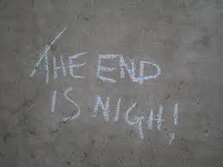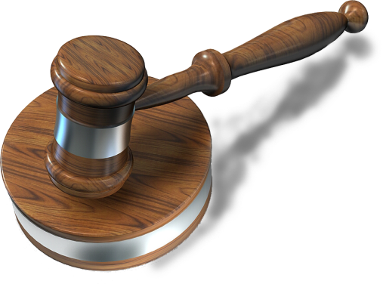

The last thing you need to determine is how your patient’s morphine concentration compares to the average morphine dosage. If higher than the average dose then there is evidence of foul play. If lower than the average dose then it is typical medical procedure.

# Last Steps

1. Based on your results and your calculation above is the patient ppm higher or lower than the average dosage? What does this mean?
2. How do you determine the % concentration of something? Give an example of how this works.
3. What is a calibration curve used for? Give an example of when you would need a calibration curve.
4. **Write a conclusion statement to a jury about Dr. Harold Shipman. Include all relevant information from this lab including background information, procedure, calculations, and data and graphs to convince the authorities of Dr. Shipman’s guilt or innocence. This statement should summarize the lab in full detail with a stated conclusion of your results!**

## Conclusion

You now have all the information you need to make an informed, data driven, and proof backed decision on the fate of Dr. Shipman.

Judgment

Case #2341

The Doctor of LIfe or Death