**Lab #36: Solutions and Beer’s Law Lab – Finding the Molarity of Kool-Aid (Investigation 9B Follow Up)**

*Materials*

* 5-6 cuvettes
* 50mL of premade Kool-aid
* 2, 100mL graduated cylinders
* 1 pipette
* pencil or tape
* LabMaster
* distilled water
* 6, 50mm test tubes
* test tube rack
* droppers

**Part 1: Pre-Lab**

*Annotate the following information*

*How can Beer’s law be used to calculate the molarity of Kool-aid?* Concentrated solutions can be mixed with solvent to make weaker or dilute solutions. This is the kind of thing people do every day with consumer products like fruit juice. Some concentrated solutions are used as "stock" solutions. Weaker solutions are typically used but the concentrated solutions require less storage space. In recent years accidents have occurred in the health care professions when dilutions were done incorrectly. Some of these errors have resulted in deaths or serious injuries. A number of health care facilities do not want to take the risks associated with errors in preparing diluted solutions. A relationship exists using the equation M1V1 =M2V2. This relationship is used to determine the number of moles of solute in a known volume of solution. The volume is converted to liters. You will use this relationship and a calibration curve. The calibration curve will be used to determine **the Perfect Concentration of Kool-Aid!**

1. According to the reading, dilutions that are done incorrectly can be harmful. In what scientific fields do you think those errors can be harmful? Why?



1. List the ingredients that you believe are in Kool-aid. Place a star next to the two ingredients that you think are most responsible for Kool-aid’s overall mass.
2. What is a stock solution?
3. What is the difference between a dilute and a concentrated solution? Explain using the terms solute and solvent. (Hint: you may need to look these words up in your book!)

**Part 2: Preparing your solutions to find the molarity of pre-made kool-aid.**

*Your teacher has prepared a super concentrated stock solution of Kool-aid. You will use this solution to begin your dilution series.*

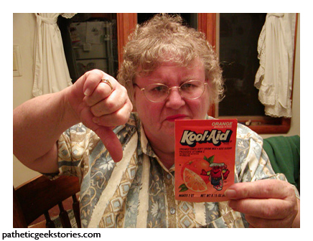

***Molarity of Stock Kool-aid sample (M1): ______________***

Use this stock solution to prepare 20 mL of each of the following solutions: 0.1M, 0.4M, and 0.7M



**Creating 20 mL of the 0.7 M solution:**

1. How much stock solution do you need to make 20 mL of the 0.7 M solution? Show your work here:

**What do you know?**

M1=

V1=

M2=

V2=

1. After referencing (calibrating) your spectrophotometer, record the absorbance value on the table below.
2. Repeat step #1 for the 0.1M and 0.4M solutions.

(Show all work here and record the absorbance data in **Table 1**)

**Table 1:**

|  |  |  |  |  |
| --- | --- | --- | --- | --- |
| **Solution** | **Volume of 1.0M stock solution**  **(mL)** | **Volume of Distilled water added**  **(mL)** | **Concentration**  **(M)** | **Absorbance** |
| 1 | 20 | 0 | 1.0 |  |
| 2 | 14 | 6 |  |  |
| 3 | 8 | 12 |  |  |
| 4 | 2 | 18 |  |  |

**Part 3: Calibration Curve**

1. Make a graph using the provided graph paper that plots absorbance units (AU) vs. molarity (M). Molarity should be on the x-axis and absorbance units should be on the y-axis. Title your graph: *Calibration Curve for Kool-Aid.*

**Title: ___________________________________________________**

**y axis:** _____________________________________



**x axis:** _____________________________________________

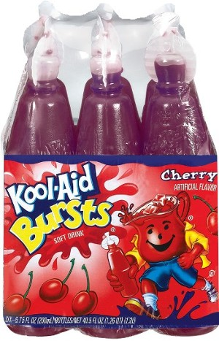**Part 4: Determining the unknown using your graph!**

1. A perfect concentration of Kool-Aid (with an unknown Molarity- oh no!) was pre-made by the manufacturer. Obtain the unknown solution of Kool-Aid!
2. Measure the absorbance for the perfect solution and record in the space below. (Don’t forget to take a reference first with water!)

Kool Aid Squeeze It Sample: Abs = _____________

**_______ Concentration of unknown (but perfect!)**

**Kool-Aid solution (from graph)**

**Part 5: Making the Perfect Kool-aid to quench your thirst.**

1. The stock kool-aid is way too concentrated to drink. How would you make yourself a 50mL glass of perfect Kool-aid (matches the pre-made kool-aid) using the 1.0M stock Kool-aid?

**Show your work**:

**Part 6: Thinking it through**

1. Often times, students get ‘J’ shapes on their concentration absorbance graphs. They usually get poor data with very low concentrations. Propose an explanation for this source of error.
2. Kool Aid is red, since it is red what would be the optimum wavelength to run our standard solutions? and Why?
3. What is the trend you observed between concentration and absorbance?
4. 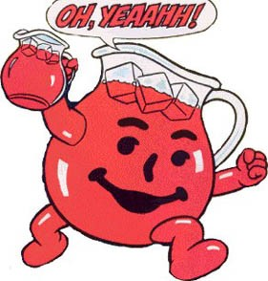Imagine that you like your Kool-aid to be 50% sweeter than the “ideal” Kool-aid. How could you make this Kool-aid from the stock? (Show your work)
5. In each experiment, you have changed your Molarity by adding water. What would happen to the Molarity of a solution if you **boiled off** some of the water?