The Chemical Formula
Paper, glass, plastic, metal, skin, leaves, it’s all matter and it’s all made out of the same 92 ingredients. In fact, only six elements make up most everything around us. How does such incredible variety come from only a few elements? Well, think about it as a dictionary. How do so many words from only 26 letters? The answer for matter is very similar and the chemical formula is how we “spell” all the different kinds of matter with the same few elements.
Materials
Atomic model kit
calculator
periodic table
- What is a chemical formula and how is it used?

Setting up your model
Color | Element
Black | Carbon
White | Hydrogen
Red | Oxygen
Blue | Nitrogen
Green | Chlorine
Yellow | Sodium

Making some models and “spelling them”
- Pick any four atoms. Use the “bonds” to connect them. Make sure all empty holes are filled.
- Draw in the diagram below for the “molecule” you have made.
- Use the big boxes and subscript boxes to work out the chemical formula for your molecule.
- Write the completed formula on the line.

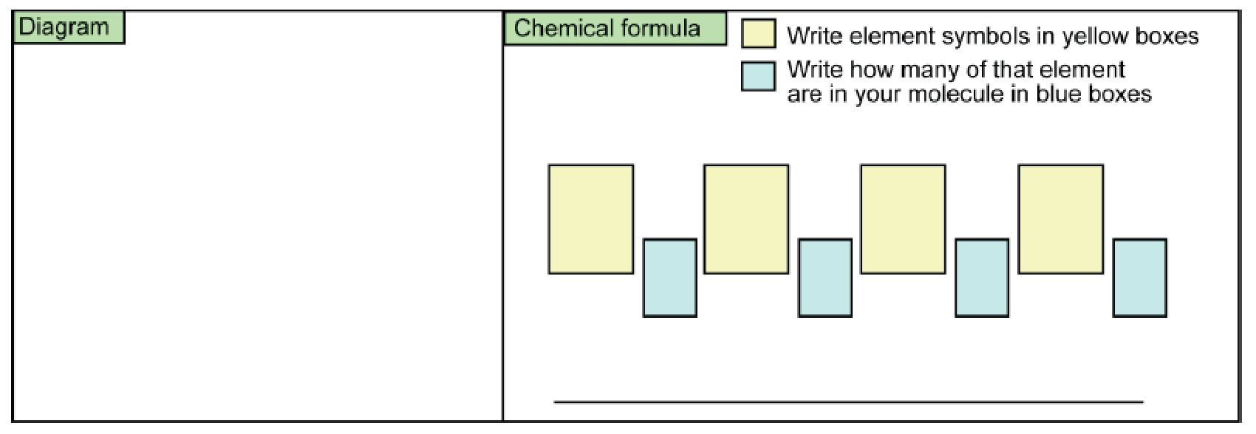

Part 3: Bigger molecules
- Using 6 atoms build a molecule with 2 pairs (a pair is 2 atoms that are the same).
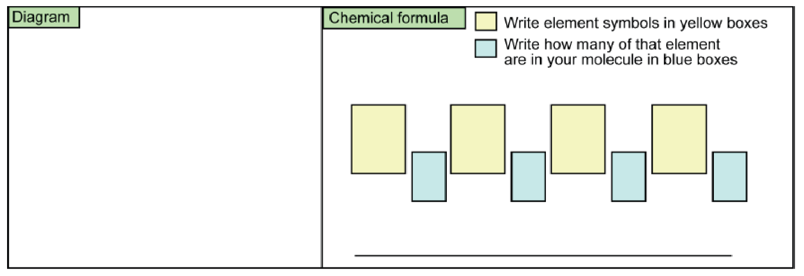
- Using 6 atoms, build a molecule that has three-of-a-kind (three atoms the same).

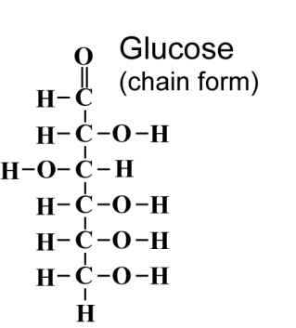
Part 4: Reflecting on what we learned
- How many total atoms are in the glucose molecule?

- Write the chemical formula for glucose.

- Methane has a chemical formula CH₄. Draw a possible chemical diagram for a methane molecule. HINT: Carbon makes 4 bonds with other atoms.

- Write a chemical formula for a molecule that has 4 hydrogen atoms, 2 carbon atoms and 2 oxygen atoms.
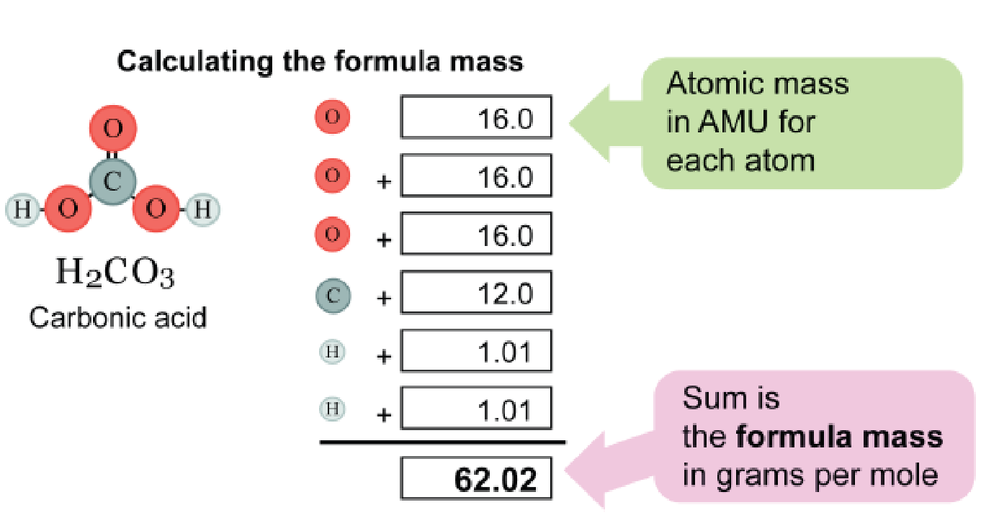
Part 5: The formula mass
- Each atom has mass
- The masses are different for atoms of different elements that can be found on the periodic table.
- Each molecule must also have a mass that depends on both its chemical formula and the mass of its individual atoms.

Element | Average atomic mass (amu)
carbon-BLACK | 12.0
oxygen-RED | 16.0
hydrogen-WHITE | 1.00
chlorine-GREEN | 35.5
sulfur-PINK | 32.1
nitrogen-BLUE | 14.0
sodium-YELLOW  fluorine -YELLOW | 23.0
 | 19.0
The chart is now expanded to include the average mass of each atom in atomic mass units. An atomic mass unit is roughly equal to the mass of a single hydrogen atom. Carbon is about 12 times as heavy as hydrogen; oxygen is about sixteen times as heavy and so on.

Part 6:

 | NH₃ |  | Diagram
 | Formula Mass
 | CO₂ |  | Diagram
 | Formula Mass
 | H₂S |  | Diagram
 | Formula Mass
 | CCl₂F₂ |  | Diagram
 | Formula Mass
 | CH₃OH |  | Diagram
 | Formula Mass
 | C₆H₆ |  | Diagram
 | Formula Mass
 | H₂CO₃ |  | Diagram
 | Formula Mass
 | HCN |  | Diagram
 | Formula Mass

