Name:_______________________ Date:_____________________ Hour:___________________

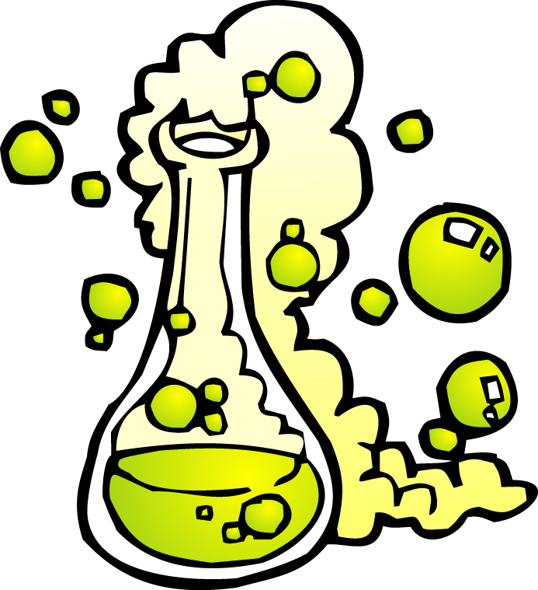
Follow Up What is a Chemical Reaction?

Questions
- What are the four signs of a chemical change? Give an example of each from the reactions observed.
______________________________________________________________________________________________________________________________________________________________________________________________________________________________________________________________________________________________________________________________________________________________________________________________________
______________________________________________________________________________________________________________________________________________________________________________________________________________________________________________________________________________________________________________________________________________________________________________________________________

- Classify the following everyday process as chemical or physical changes:
  - Nail rusts ________________________
  - Ice melts _________________________
  - Wood burns________________________
  - Banana ripens________________________
  - Sugar dissolves in water________________________

- Which one was your favorite chemical reaction and why? Can you predict what you made? If yes , try to identify the product(s).
______________________________________________________________________________________________________________________________________________________________________________________________________________________________________________________________________________________________________________________________________________________________________________________________________

Writing Reactions- Write the following reactions in symbol form.

- Iron metal added to aqueous copper (II) sulfate yields aqueous Iron (II) sulfate and copper metal.

- Aqueous potassium chloride is mixed with aqueous silver nitrate to make aqueous potassium nitrate and aqueous silver chloride.
- zinc metal reacts with oxygen from the air to make solid zinc oxide

- Aqueous aluminum sulfate and barium chloride dissolved in water yields aluminum chloride aqueous and aqueous barium sulfate.

- Solid Aluminum oxide breaks down to make solid aluminum and Gaseous oxygen.

- Gaseous Phosphorus combines with oxygen gas to make liquid diphosphorus pentoxide.

- Aluminum metal reacts with iron (II) oxide powder to produce aluminum oxide solid and iron metal.

- Ammonia gas (NH₃) plus oxygen gas yields nitrogen monoxide gas plus water vapour.

- Aqueous sodium hydroxide and carbon dioxide gas yields sodium carbonate solution and liquid water.

Write the following reactions in sentence form
- NaOH(aq) + HCl(aq) NaCl(aq) + H₂O(l)

- 2H₂ (g) + O₂(g) 2H₂O(l)

- Mg (s) + CuCl₂(aq) MgCl₂(aq) + Cu (s)

- CuCl₂(aq) + 2 NH₄OH (aq) Cu(OH)₂(aq) + 2NH₄Cl (aq)

