Lab #30: Percentage of Water in Popcorn!
Materials
- Popcorn Bag
- Microwave

Part 1: Pre-Lab
Annotate the following information
Popcorn, a cereal grain like wheat or oats, is about 75% carbohydrate (starch) while the other 25% is composed of protein, fat, minerals, and water. The water plays a critical role in the popping process. When heated, the moisture inside the popcorn kernel turns into steam. The hard outer covering of the kernel acts like a seal, causing a build-up of pressure inside the kernel. When the pressure gets high enough, the kernel explodes and the starch rapidly expands to create the fluffy popcorn. To ensure maximum popping expansion, the corn is carefully cured (dried) until it reaches a certain percentage of water, which you will determine in this lab.

Prelab Questions:
- What are the compositional (parts) percentages of popcorn?

- Describe how popcorn pops in 2 sentences?

- What is the purpose of this lab?

- Based on the reading and prior knowledge make a hypothesis (educated guess) about what percentage of water makes up a popcorn kernel. Explain why you think this!

Part 2: The Experiment --> Popping popcorn
- Find the mass of a package of unpopped popcorn. Record the mass in the data table.
- Pop the popcorn, then open the bag and allow the steam to escape. Do not eat your popcorn…you need this data!
- Find the mass of the popped corn and the bag. Record the mass.
- Find the mass of just the bag. Record the mass.
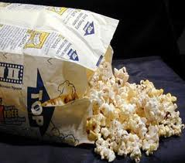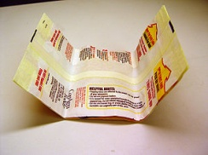
Unpopped popcorn & bag |  | grams
Popped popcorn & bag |  | grams
Mass of bag |  | grams

Part 3: Data Analysis
- Using your data calculate the mass of the unpopped popcorn (not including the bag).

- Using your data calculate the mass of the popped popcorn (not including the bag).

- 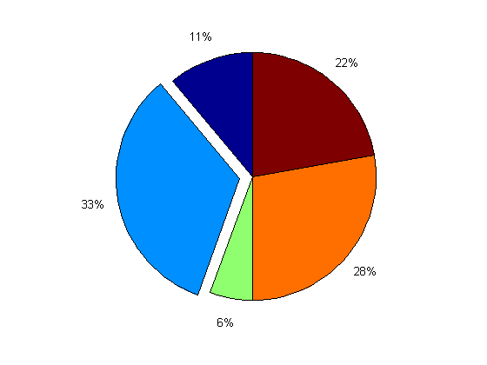Using the answers to your previous calculations calculate the mass of the water lost by popping your popcorn.

- Find the percentage of water in your popcorn: 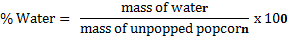

- How does this value compare to the prediction you made in the prelab?

- Calculate the formula mass for water.

- How many moles of water were boiled off by the heat of the microwave?

- Starch can be written as (C₆H₁₀O₅). Find the formula mass of C₆H₁₀O₅.

- Assume the popped popcorn is pure starch. How many moles are there in your sample?

- If you had 2.5 moles of starch (C₆H₁₀O₅), how many grams would that be?

- Explain to me, in your own words, what makes popcorn pop?

- Is popping popcorn a physical or chemical change? Explain your answer.

- Make a hypothesis for what will happen in the following two scenarios:
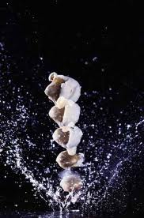
- There is too little water inside the popcorn kernel being popped.

- There is too much water inside the popcorn kernel being popped.

