**The Lemon Battery**

*Materials*

* One lemon
* A light emitting diode (LED)
* A 5cm piece of Cu wire
* A 5cm piece of Mg wire
* Two clip-leads
* The LabMaster
* Voltage Probe

**Part 1: Pre-Lab**

Everything on Earth stores and uses energy to stay alive. The ultimate source of this energy is the sun. By what process does life collect and store its energy? We, and the lemon, are both living batteries!

The lemon battery is called a **voltaic battery**, which changes chemical energy into electrical energy. The battery will be made up of two different metals (see the picture below). These are called **electrodes**, which are the parts of a battery where electric current enters or leaves the battery. The electrodes are placed in a solution that can conduct electricity, like the acid in the lemon.

In the acid, an excess of electrons collects on one end of the electrodes. At the same time, electrons are lost from the other electrode. In this experiment you will see how the process of energy storage (and use) in living things is described by electrochemistry!

**Part 2 Pre Lab Questions:**

1. What particle causes the flow of electricity?
2. In your own words, describe what happens when using **electrochemistry**?
3. Predict how you think we can use electrochemistry to make energy. Explain.
4. What will you be doing in this lab?



**Part 3: Making a lemon light up**

1. Roll the lemon on a table so that the juice can flow easily.
2. Make two small incisions on the lemon about 2cm apart.
3. Insert the piece of magnesium and the piece of copper in the lemon.
4. Use the clip-leads to connect the leads of the light-emitting diode (LED) to the copper wire and magnesium wire.
5. At this point the LED should light up, if it does ***not***, switch the way that the LED leads are connected to the copper and magnesium. The direction is important!

**Part 4: What just happened?**

1. Why did the LED light up?
2. Explain where you think the electricity came from.

**Part 5:** **Try something new!**

1. What happens if you replace the magnesium ribbon with a copper wire? (You’ll have two pieces of copper in the lemon and no magnesium)
2. What happens if you replace the copper wire with magnesium ribbon? (You’ll have two pieces of magnesium in the lemon and no copper)
3. What happens to the light if you use two copper wires **and** two magnesium wires at the same time?

**Part 6: Let’s measure the electricity that comes out of the lemon**

|  |  |
| --- | --- |
|  | Voltage (volts) |
| 1 Cu Wire & 1 Mg Ribbon |  |
| Reverse  1Cu Wire & 1Mg Ribbon |  |
| 2 Cu Wire & 2 Mg Ribbon |  |
| Reverse  2 Cu Wire & 2Mg Ribbon |  |

1. Connect the red alligator clip of the voltage probe to the copper wire and the black to the magnesium ribbon.
2. Connect the voltage probe to the probe system, measure and record the voltage.
3. Now reverse the red and black alligator clips, measure and record the voltage again.
4. Insert a second copper wire and a second magnesium ribbon, measure and record the voltage.
5. Now reverse the red and black alligator clips, measure and record the voltage again.

**Part 7: Why did you observe this?**

1. What happened to the voltage reading when you inserted the second piece of Cu wire and Mg ribbon?
2. 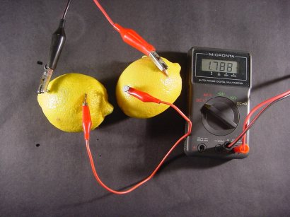How can you explain the increase in the intensity of the light given you answer to part a above?
3. If the two pieces of metal that are inserted into the lemon are the same, the LED does not light up. Propose an explanation for why this might be the case.
4. Look closely at the place where the Mg and Cu are inserted into the lemon. What do you notice? What gas do you think is forming to create what you observe?
5. What if this setup were a battery instead of a lemon? Besides electricity, it also generated gas. What can you say about the efficiency of this battery? Is it a good thing, a bad thing or it doesn’t matter, that it also generates gas? Explain.