**Le Chatelier’s Principle**

**Part 1: Background**

What are the four factors that affect equilibrium and how do they affect it?

1.

2.

3.

4.

Practice:

1. Which direction would each of the following shift the reaction?

CH4(g)+ 2H2S(g)⇄ CS2(g) + 4H2(g)+ heat

* 1. Decrease the concentration of dihydrogen sulfide
  2. Increase the pressure on the system
  3. Increase the temperature of the system
  4. Increase the concentration of carbon disulfide
  5. Decrease the concentration of CH4
  6. Volume is increased

**Part 2: Setting up for Le Chatelier’s and Temperature.**

1. You should see a hot water bath, ice water bath, and a test tube with a purple aqueous solution on your lab table.
   1. If your water is not hot please turn up your hotplate to a reasonable setting. If it is not half full of water add more.
   2. If your ice is all melted please get more to add to the ice bath. If it is more than half full pour some water out.
   3. If your solution is not purple or is missing please tell your instructor.

**Part 3: Le Chatelier’s and Temperature.**

1. 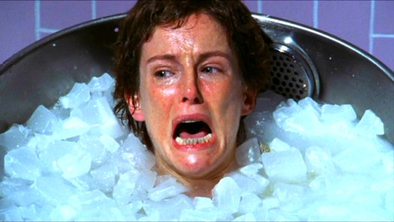The purple solution you see is Cobalt (II) Chloride dissolved in water. Concentrated acid has been added to this to create the equilibrium equation below.

Co(H2O)6 (aq) + 4Cl (aq) CoCl4 (aq)+ H2O (l)

1. Place the test tube in the cold water bath and record what happens in data table 1.
2. Place the test tube in the hot water bath and record what happens in data table 1.
3. You may do this several times if you wish.
4. In the equation above the reactant side with Co(H2O)6 is pink when in high concentration. The product side with CoCl4 is blue when in high concentration. Use this information to fill in the rest of data table 1

**Data Table 1**

|  |  |  |
| --- | --- | --- |
| **Water Temperature** | **Color** | **Reactants or Products?** |
|  |  |  |
|  |  |  |

**Part 4: Analyzing Le Chatelier’s and Temperature**

1. What does it mean when a reaction is endothermic moving from reactants to products? What does it mean if it is exothermic? What side of the equation is heat on for each?
2. When you put the solution in the hot water what color did it turn? Does this put heat on the reactant or product side?
3. Based on this information and your observations is the reaction endothermic or exothermic?
4. Describe what is happening to the molecules when you raise the temperature. (Hint: Think about the book reading and collision theory.)

**Part 5: Setting up Le Chatelier’s and Concentration**

1. Measure out 5.0mL of Milk of Magnesia and place in a 100mL beaker.
2. Add 1.0mL (~20drops) of universal indicator and swirl. Make observations in data table 2.
3. Add 1 drop of 1.0M HCl. Look at it and then swirl. Make observations and record data in table 2.
4. Slowly add 20 drops of 1.0M HCl and swirl between each drop. Make observations and record data.
5. Your chemicals should now be close to an equilibrium point. As you add drops you will notice that the color change is slower than before. If you add too much in the next steps you will push the reaction to far. Add a few more drops of 1.0M HCl and swirl. Make observations and record data until the solution stays red.
6. Set the solution aside and keep until the end of the class period or your teacher calls you back.

**Data Table 2**

|  |  |  |
| --- | --- | --- |
| **Step** | **Observations/Data** | **Reactants or Products?** |
| 2 |  |  |
| 3 |  |  |
| 4 |  |  |
| 5 |  |  |
| 6 |  |  |
| 7 |  |  |
| 8 |  |  |

**Part 6: Analyzing LeChatelier’s and Concentration**

The chemical reaction you just preformed is an acid base reaction. The equilibrium between Milk of Magnesia (Mg(OH)2) and Hydrochloric acid (HCl) is based on pH. In the presence of a universal indicator a low pH is acidic and shows as a redish color. A high pH is basic and shows as a bluish color. The color changes depending on there being more base or more acid present. This is described as the equation below.

Mg(OH)2 HCl

1. Label the reactant and product above with an acid side and a base side.
2. Using the color and this as a guide and the equation above fill in the rest of table 2.
3. As you add HCl into the beaker what color did the solution turn? Does this mean there was more acid or base?
4. What happened as you swirled the solution? Does this mean there was more acid or base?
5. Based on Le Chatelier’s principle why does the solution go from red and back to blue over time?

**Part 7: Conclusion**

1. In lab today you titrated 5.0mL of Milk of Magnesia with ~10.0mL of HCl. Without looking at a chemical equation what do you think the molar ratio is between the Magnesia and HCl? Why do you think this?

**Use the following equation and answer the questions below.**



1. If the reaction is endothermic moving from reactants to products and we add heat what color would the solution be and why?
2. If we increased the amount of FeSCN in the reaction describe what would happen using Le Chatelier’s principle. (Hint: 2 things should happen. Initial and over time.)