**Lab #22: Lewis Structures (Investigation 7A)**

*Materials*

* Molecular Modeling Kit
* Periodic Table

Atoms combine to form molecules because of energy. The atoms that combine have lower energy together as a molecule than they do apart as pure elements. Atoms combine, forming molecules by sharing or giving up electrons. Since the atoms of each element have a unique structure of electrons, different elements form types of bonds.

**Part 1: Introduction**

The diagram below shows diagrams and valence for the first 11 elements. Elements form chemical bonds to reach a stable configuration of 8 valence electrons.



1. How many bonds should a hydrogen atom normally make?
2. How many bonds should a lithium atom normally make?
3. How many bonds should a carbon atom normally make?
4. How many bonds should a nitrogen atom normally make?
5. How many bonds should an oxygen atom normally make?
6. How did you determine your answers for parts a through e?

**Part 2: Discovering your model set**

Your molecular model set contains eight different sized balls that represent eight different elements. Using clues, such as size and the number of bonds that can be formed with each ball, determine the element that is represented by completing the table. Use the elements from diagram 1 above. Please do not duplicate any element.

|  |  |  |  |
| --- | --- | --- | --- |
| Color | # of Bonds (holes) | # of Valence Electrons | Element |
| White |  |  |  |
| Pink |  |  |  |
| Orange |  |  |  |
| Blue |  |  |  |
| Red |  |  |  |
| Black |  |  |  |

**Part 3: Molecule and Lewis structures**

Build the following molecules from their Lewis dot structures.

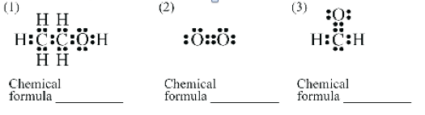

1. How many bonds does each carbon form?
2. How many bonds does each hydrogen form?
3. How many bonds does each oxygen form?

**Part 4: Lewis structures from models**

Create Lewis dot structures, chemical formulas and structural diagrams for each model made by your teachers/

|  |  |  |  |  |
| --- | --- | --- | --- | --- |
|  | Model 1 | Model 2 | Model 3 | Model 4 |
| Chemical Formula |  |  |  |  |
| Lewis Dot Structure |  |  |  |  |

1. How do you think the periodic table is organized?
2. Sodium, Na, is a reactive element. Based on what you have learned in this lab, why do you think sodium is so reactive?
3. Chlorine, Cl, is also a reactive element. How is chlorine different from sodium? Why do you think chlorine is reactive as well?