MODELS OF THE ATOM
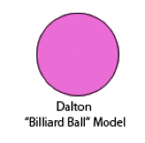 | 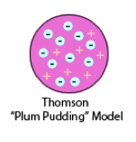 | 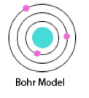 |  | 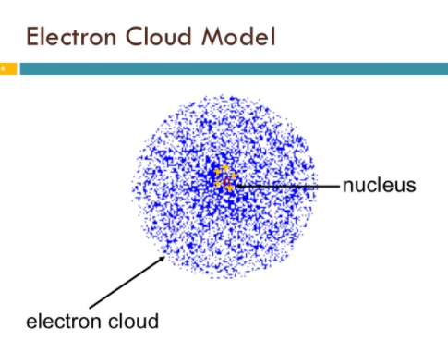
Year Developed: | Year Developed: | Year Developed: | Year Developed: | Year Developed:
Description: | Description: | Description: | Description: | Description:
Positives: | Positives: | Positives: | Positives: | Positives:
Negatives: | Negatives: | Negatives: | Negatives: | Negatives:

