Name:________________________________Hour:______
What is pH?
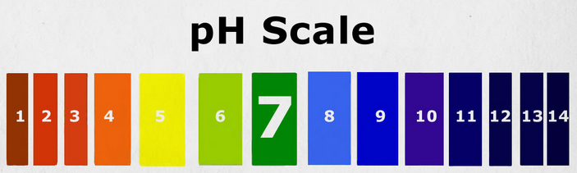

1. Acids contain _____________________

2. Bases contain_____________________

3.Label the acids, bases, and water on the pH scale.

4. Hydrochloric acid (HCl) and Sodium Hydroxide (NaOH) are mixed together.
a. Write the balanced chemical equation.

b. Which chemical is the acid?

c. Which chemical is the base?

d. The reactions between acids and bases are called neutralization reactions. Why?

e. What do you think the pH of the product would be if you put equal amounts of acids and bases?

pH Calculations and Measurements
pH tells us how many hydrogen ions, H+ are in a solution.
We write amount of H+ ,or the concentration of H+, with brackets like this: [H+]
[H⁺] tells us whether the solution is acidic, basic or neutral.

- Calculating pH:
To determine the pH we use the equation: pH = -log[H+] .

- A sample of apple juice has a hydrogen ion concentration of [H⁺] = 1.9 ⋅ 10⁻⁴ M
Calculate the pH of this apple juice.
Record your answer. pH = ___________

Is this an acid or a base?

- Fresh squeezed orange juice contains a concentration of 3.16 ⋅ 10⁻⁴ M of H⁺ ion. Calculate the pH of this orange juice by following the steps below.
Record your answer. pH = ___________

Is this an acid or a base?

- A sample of fresh sea water contains a concentration of hydrogen ions, where
[H⁺] = 6.2 ⋅ 10⁻⁹ M.
Calculate the pH of this sea water sample.

Record your answer. pH = ___________
Is this an acid or base?

pH allows us to interpret very small concentrations like the ones above as a number 1-14 on the pH scale. Use your text chapter 13 for help if you need it.
- Compare the pH of sea water (#3) to orange juice (#2).
- Which one has a larger amount of hydrogen ions? ______________
- How does the amount of H+ affect the pH? Circle your answers to complete this sentence: The (more/less) H+ the (higher/lower) the pH.
a) water
b) neutral
c) acid
d) OH
- Matching:
- ______ A substance that has a pH below 7.

- ______ A substance that can act as an acid or a base.

- ______ Bases release larger amounts of this ion in solution than acids do.

4. ______ A solution that has a pH equal to 7.

Constructing a pH Scale

- Procedure:
- Your teacher has set up your well plate and cut several small strips of pH paper. (Refer to key)
- Test each of the available solutions by using tweezers to dip a strip of pH paper to test the pH. Carefully keep track of which solution you are testing.
- After testing the solution take your litmus paper strip and match it up to the appropriate color on the test chart. Record the pH that is the closest to your color. Throw your litmus paper out.
- Repeat for each solution.
Substance | Color of pH paper | pH value (#)
Cleaning solution
Lemon juice
Milk of Magnesia
Black Coffee
Bleach
Baking soda
Cola
Fruit Juice
Tap Water

- Understanding
- Are there any substances that surprised you? If so which one(s).

- Which of the substances was the most acidic? __________________. How do you know?

- Which substance was the most basic? _____________________. How do you know?

- Did anything you tested have a pH close to 7?____________ If so which one(s)?

- What color does a litmus paper turn when placed in an acid?

- What color does litmus paper turn when placed in a base?

- What ions are present when the solution is acidic?

- What ions are present when the solution is a base?

