Name: _____________________________ Hour: ______

Poisoning the Star Athlete
Case #2101
Lab #35
Controversy
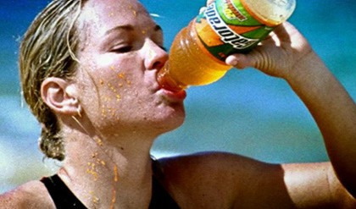
A star athlete at our school became ill during a critical tournament contest. It was reported that the athlete suffered from “flu-like” symptoms, and was treated and released after spending the night in a local hospital.
Laboratory results from the hospital have not been analyzed yet, but one doctor suggested that the athlete could have ingested a sufficiently large amount of copper (II) sulfate to cause severe gastrointestinal distress.
When interviewed by the local police, the athlete said that one of the bottles of sports drink in the locker room tasted “slightly off”, but thought nothing of it until being stricken with nausea and cramps.

Investigators
Different sports drinks in the locker room were collected. It will be your job to use a spectrometer to test each sport drink and determine if one had been laced with copper (II) sulfate. The problem is complicated by the facts that copper (II) sulfate imparts a blue color to water when it is dissolved, and many sports drinks contain blue food dyes with colors that look very similar to copper (II) sulfate. In this lab you will learn to measure absorbance spectrum, create standards for common food dyes to analyze, and determine if the athlete was poisoned.
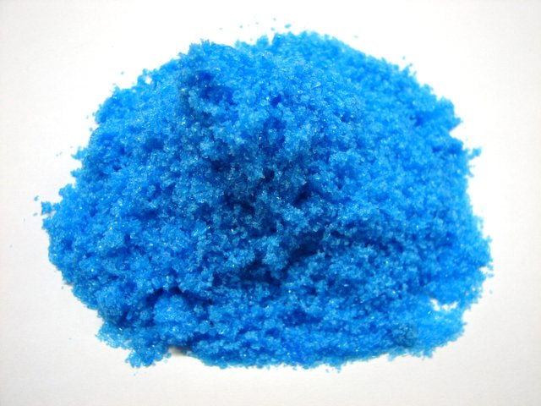
Background information:
Toxicological Effects
Copper sulfate is an irritant. The usual routes by which humans can receive toxic exposure to copper sulfate are through eye or skin contact, as well as by inhaling powders and dusts. Skin contact may result in itching or eczema. Eye contact with copper sulfate can cause conjunctivitis, inflammation of the eyelid lining, ulceration, and clouding of the cornea.
Upon acute oral exposure, copper sulfate is only moderately toxic. According to studies, the lowest dose of copper sulfate that had a toxic impact on humans is 11 mg/kg of body weight. Because of its irritating effect on the gastrointestinal tract, vomiting is automatically triggered in case of the ingestion of copper sulfate.
However, if copper sulfate is retained in the stomach, the symptoms can be severe. After 1–12 grams of copper sulfate are swallowed, such poisoning signs may occur as a metallic taste in the mouth, burning pain in the chest, nausea, diarrhea, vomiting, headache, discontinued urination, which leads to yellowing of the skin. In case of copper sulfate poisoning, injury to the brain, stomach, liver, or kidneys may also occur.

A Little Bit about Spectroscopy:
Your food dye sample will look similar to the graph. In this example, the spectrometer projects light toward the cuvette of Red 40 solution and the molecules in the solution allow some of the wavelengths of light to pass through the sample and reach the spectrometer’s detector. The graph shows you that, in order for your eyes to see a red liquid, certain wavelengths (colors) of light are absorbed and others are not. Note the colors (wavelengths) where the peaks appear on the graph. As you test other food dyes, you will see why these liquids display their particular colors.

Red 40 Spec
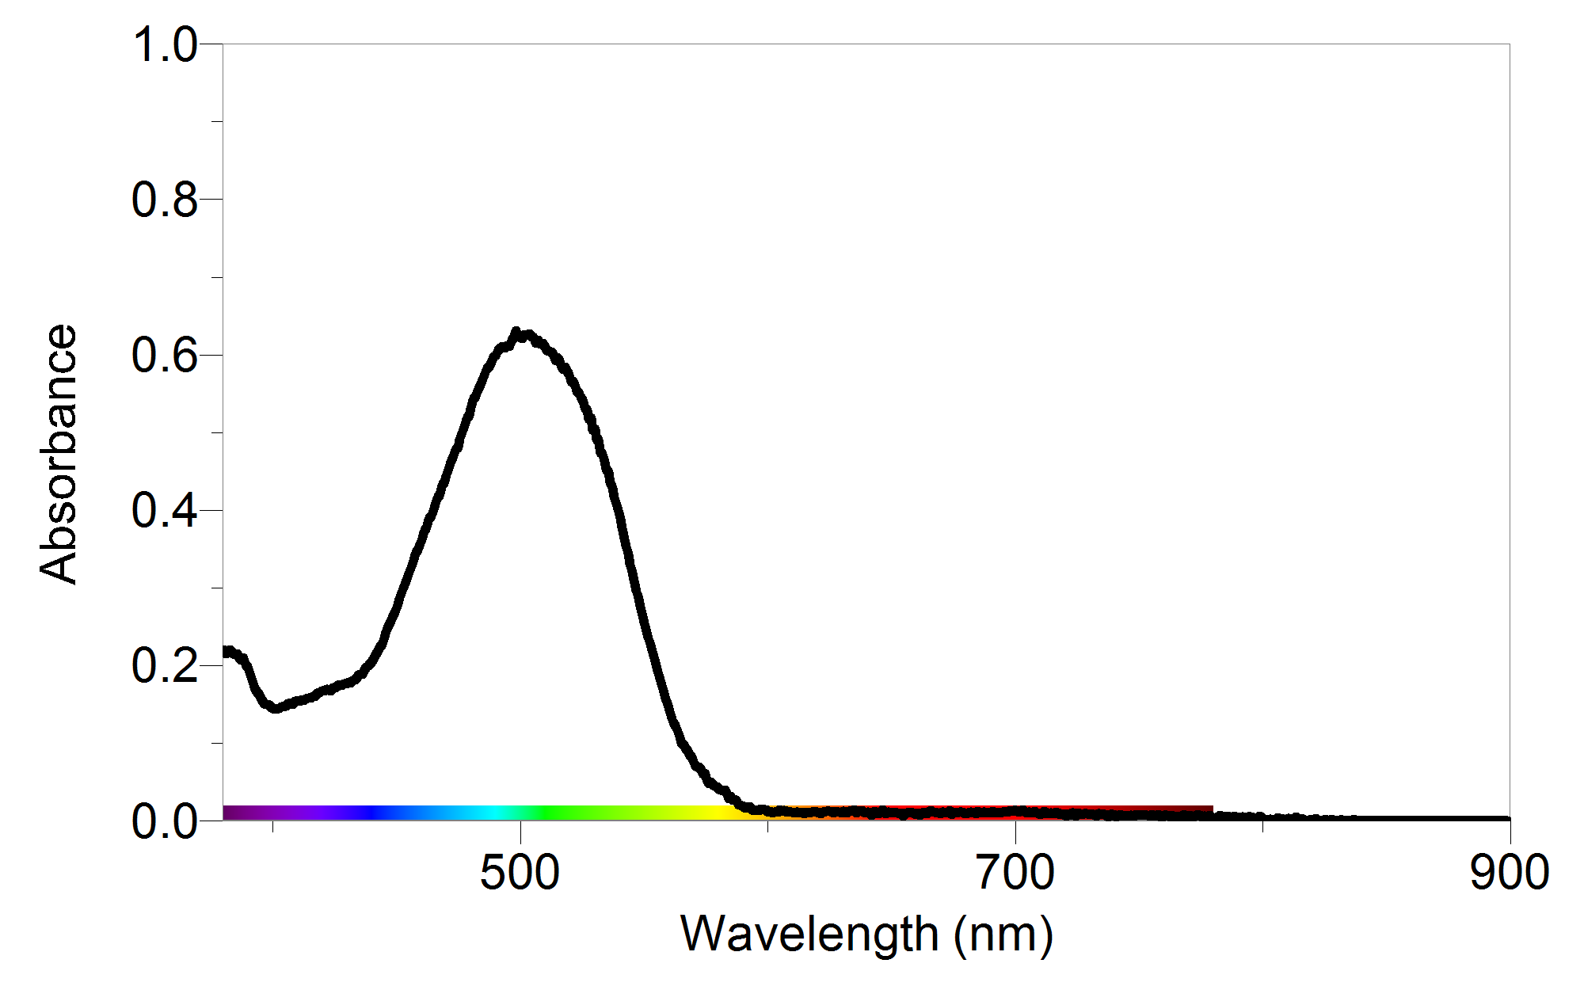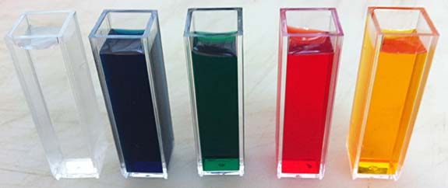
PRE-LAB QUESTIONS:
- According to the second paragraph, what is the lowest dose of copper sulfate that has a toxic impact on humans?

- Explain why a set of standard absorbance spectrums, are needed to be obtained in your quest to determine the poisoned drink?

- Looking at the graph above, what is the absorbance reading at 500nm?

PROCEDURE
PART I Measure the Absorbance Spectra of the Standard Solutions
- Obtain and wear goggles.
- Use a USB cable to connect a Vernier SpectroVis spectrometer to a LabQuest 2.
- Turn on the LabQuest 2. At the meter screen, tap File and choose New.
- Obtain a sample of the Red dye.
- Calibrate the spectrometer
  - Prepare a blank by filling an empty cuvette ¾ full with distilled water. Place the blank cuvette in the Spectrometer
  - Choose Calibrate: USB Spectrometer from the Sensors menu. The following message is displayed: “Waiting 90 seconds for lamp to warm up.” After 90 seconds, the message will change to “Warmup complete.”
  - Select Finish Calibration. When the message “Calibration completed” appears, select OK.
- Measure the absorbance of the red food dye.
- Write down the name of the food dye sample you tested and “draw” the graph lines into the graphs pictures below.
- Repeat the process for the rest of the food dye samples and the poison (CuSO₄)

DATA COLLECTION:
Red Dye: | Blue Dye:
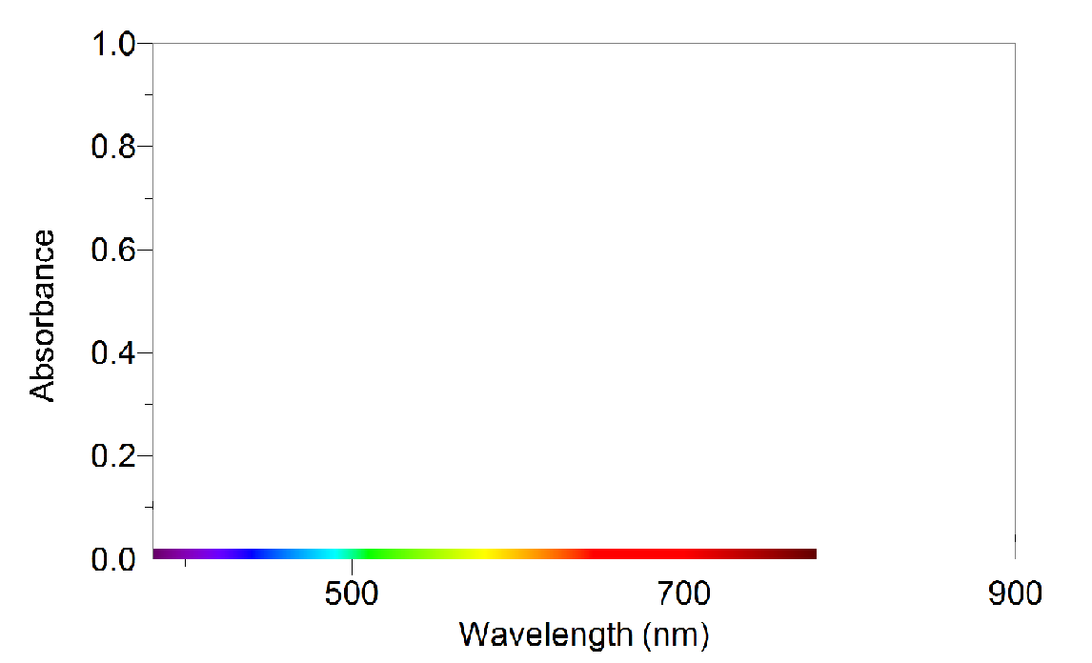
Green Dye: | Yellow Dye:
Copper Sulfate

Questions:
- Emphasize the feature of each spectrum that distinguishes it from the other food dyes.

- Is there is a relationship between the color you see and the colors absorbed? If yes, explain.

- Color is a very important factor in marketing a new product, and exact color compositions are closely guarded trade secrets. Suggest a way that you might figure out what gives Gatorade its distinct color.
PART II Measure the Absorbance Spectra of Gatorade Samples:
- Repeat the absorbance spectral analysis from Part I for the Gatorade samples.
- Record your observations and graphs in the table below.
Gatorade Name 1: | Gatorade Name 2:
Gatorade Name 3: | Gatorade Name 4:

POST LAB QUESTIONS:
- Describe, in detail, the absorbance spectrum of each food dye sample and the CuSO₄ solution. Emphasize the distinguishing features of each spectrum. Include the wavelengths and absorbance values of every peak in the graph of each food dye.

- Identify the food dye or dyes present in the sports drinks that you tested. Support your identification with specific information from your testing.

- Identify the specific bottle of sports drink that was “poisoned” with the CuSO₄ solution. Support your identification with specific results from your testing.

- Was the data you collected qualitative or quantitative? Explain your answer.

- If you could only look at one wavelength when testing for blue food coloring, what wavelength would it be and why?

