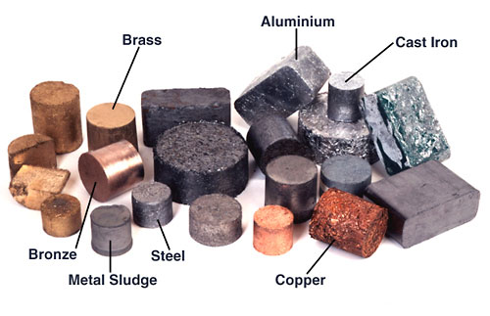
Name: _______________________ Hour: ________

Specific Heat Set
Using specific heat to find an unknown metal
Lab #13

Introduction
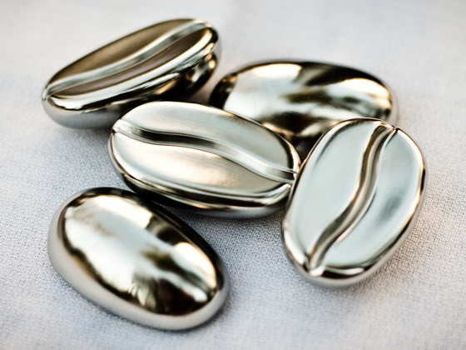
Two objects of the same mass and the same temperature can have different amounts of energy! This may seem odd, but it is true. In 2012, two guys from New Jersey took this concept and launched a business now worth millions of dollars. They call their product “Coffee Joulies”. These metal coffee beans are placed in your coffee to keep it at the perfect temperature. Coffee is served at around 180 degrees Fahrenheit. Coffee Joulies are a product that absorbs the heat from your coffee to make it a drinkable temperature within minutes. Then the product releases the heat it absorbed to keep the coffee within the perfect drinking range for twice as long as usual. They say the right temperature to drink coffee is 140 degrees. It won't burn your tongue and gives you the flavor you desire. They had $575,000 in sales last year. They expect to sell over a million dollars this year. These Coffee Joulies became so popular that the salesmen were able to pitch their product on Shark Tank!

- If you know the temperature of something, how do you think you would measure the energy in there?

- How do you think the Coffee Joulies can hold the temperature of the coffee drink?

Purpose: The purpose of this activity is to demonstrate that when five metal specimens are heated to the exact same temperature and added to a precise amount of water, the temperature will be altered differently because of the metals’ specific heat

Background:
Transfer of heat or heat flow always occurs in one direction- from a region of higher temperature to a region of lower temperatures- until some final equilibrium is reached. The transfer of this heat energy can be detected by measuring the resulting temperature change (ΔT), calculate by subtracting the initial temperature from the final temperature.

In this experiment, heat is transferred from a hot metal sample to a colder water sample. Each metal causes the temperature of the water to increase to a different extent. This means that each metal must have a different ability to absorb energy and release energy to the water causing the temperature to rise. The ability of any material to contain heat energy is called that material’s specific heat (representing by the symbol C_{p}). Specific heat is the amount of heat needed to raise the temperature of one gram of a substance by one degree Celsius. The units are J/gºC. The specific heats of the 5 metals are listed here.

Metals in Set | Specific Heat (J/gºC) | Mass of Sample provided (g)
Aluminum | 0.899 | 58.1
Copper | 0.385 | 58.2
Lead | 0.129 | 58.1
Tin | 0.222 | 58.2
Zinc | 0.385 | 58.3
The amount of heat (E) delivered by a material is equal to the mass (m) of the material delivering the heat and multiplied by the specific heat (C_{p}) and the change in temperature (ΔT). The equation can be written as:

E=MC_{P}ΔT

Procedure
- Record the physical appearance of the metal you are using in the data table. Weigh the metal sample on a scale. Record the mass in the data table.
- Place the metal sample in a boiling water bath for approximately 2 minutes to be sure the temperature of the sample is 100ºC.
- Fill a foam cup with a 50grams (50ml) of room temperature water. Record the mass in the data table.
- Record the initial temperature of the room temperature water in the data table.
- Using tongs, lift up the heated metal sample from the boiling water and carefully place it into the room temperature water in the foam cup.
- Stir the water in the calorimeter with a stirring rod or temperature probe and measure and record the highest temperature the water reaches and record it in the data table.
- Calculate the Change in temperature, ΔT, of the water. (Hint: use the background information)
- Repeat for each unknown metal.

Data Table:
Metal | Physical Appearance | Mass of metal  (g) | Mass of water  (g) | Water Temperature (initial)  ºC | Water  Temperature  (final)  ºC | Change in Water Temperature  (final-initial= ΔT)  ºC
1
2

Calculations Be sure to include units in your answer and show all work in the space below:
- Show an example calculation of the how you got the Change in Water Temperature.

- Calculate the heat (energy) gained by the water using the mass of the water. The specific heat of the water (4.18J/gºC). (Hint: use the equation in the background information). Show your work for each sample.

- Determine the heat energy that each metal lost. (HINT: Where did the water gain energy from?)

- Calculate the specific heat of each metal sample using the mass of the sample, the temperature change of the metal (Hint: initial temperature of the metal was 100ºC because it was in boiling water, the energy the metal lost was determined in #3, and the final temperature of the metal is the same as the final temperature of the water)

METAL 1:

METAL 2:

- Determine the identity of each unknown metal by comparing the specific heat calculated in the #3 to the list of values in the pre-lab reading data table.

Post Lab Questions: Answer the following questions in the space below:

- What is the purpose of this lab? In your conclusion, describe what you did in this lab to meet that purpose. Your answer should be at least four sentences. Refer to the background information to help you answer.

- Do some research with your group. What is an everyday application of the specific heat of metals? What could you use this for?

- How much energy (in Joules) is needed to heat an iron nail with a mass of 7.0 grams from 25ºC until it becomes red hot at 750ºC? (Hint: specific heat of iron 0.448 J/gºC)

- What is the relationship between specific heat and the atomic mass of the element? (USE TABLE IN PRE-LAB and the periodic table)

