*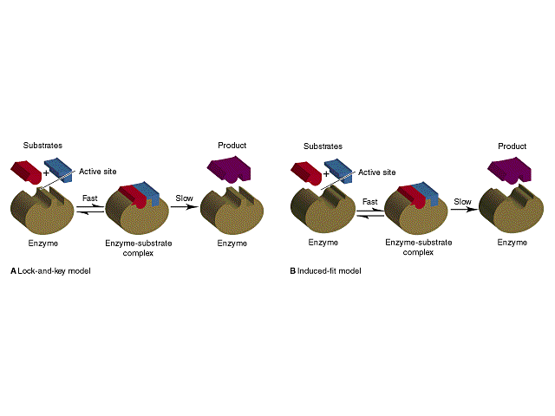***Lab #44: Reaction Rate and Concentration (12B)**

**Part 1: Pre-Lab**

*Annotate the following information*

The study of reaction rate is related to a topic in chemistry referred to as kinetics. In this experiment solid sulfur is produced as a product of a decomposition reaction. You will time how long sulfur takes to form an opaque yellow colloidal suspension. By adding different amounts of reactants you will be able to observe how the reaction rate changes. The speed of a chemical reaction depends upon several factors. Here we will investigate what effect changing the concentration of reactants has on the formation of solid sulfur.

In this experiment we use a solution of sodium thiosulfate, Na2S2O3(aq). You are familiar with sodium, but not the thiosulfate ion. The thiosulfate ion, S2O32- is a polyatomic ion similar to carbonate, CO32-. We are introducing this new ion because it is useful in learning about reaction speeds. Aqueous solutions containing the thiosulfate ion, S2O32- decompose over quickly when acid is added to them. The decomposition follows the reaction:

This reaction is very useful because as it decomposes it produces a yellow suspension of sulfur, S, that we can see with our eyes. Because sulfur is insoluble in aqueous solution, the solution will first begin to look cloudy and then become opaque. Up until now everything has seemed instantaneous. The SO2 gas produced is very soluble in water, so interestingly no bubbles are seen during the reaction even though a gas is formed!

**Part 2: Pre-lab Questions**

Before we begin, consider how a change in reactant concentration may affect the rate of our chemical reaction. Use your background knowledge of reaction rates from your text to help you here.

1. What does it mean to increase the concentration of a solution? i.e. what is being added to the solvent?
2. Make a hypothesis that states how **increasing** the concentration of one or both reactant(s) will affect the rate of reaction we are carrying out.
3. Make a second hypothesis that states how **decreasing** the concentration of one or both reactant(s) will affect the rate of the reaction.
4. What makes the reaction today with thiosulfate unique?

**Part 3: Varying Thiosulfate Concentration**

**Procedure:**

1. Assign one lab member to each role:

Person measuring thiosulfate NAME:_______________________

Person measuring Water NAME:_______________________

Person measuring Acid NAME:________________________

Person timing NAME:_______________________

2. Using your assigned roles from #1, measure out each substance for trial one with a graduated cylinder.

Once the timer is ready.

1. Place an empty beaker on the filter paper marked with a black **X**. At the same time pour the solutions into the beaker, swirl it once, and start the timer.
2. Stop the timer when you can no longer see the black **X.** Record
3. Calculate the concentration of thiosulfate ion, S2O32- and record it on table 1. You should use the dilution equation M1V1=M2V2.

M1 = 1.0M

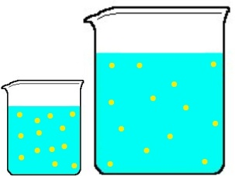V1 = the amount of thiosulfate you added

V2 = the total volume of solution

M2 = is what you are solving for.

Show at least one example of your work here:

Repeat the above steps for the rest of the trials concentrations of thiosulfate.

|  |  |  |  |  |  |
| --- | --- | --- | --- | --- | --- |
| Trial | Volume of thiosulfate (mL) | Volume of water  (mL) | Volume of Acid  (mL) | Time  (s) | [S2O32-]  (M) |
|
| 1 | 5 | 0 | 25 |  |  |
| 2 | 4 | 1 | 25 |  |  |
| 3 | 3 | 2 | 25 |  |  |
| 4 | 2 | 3 | 25 |  |  |
| 5 | 1 | 4 | 25 |  |  |

**Part 4:** **Varying Acid Concentration**

In this section we will repeat a similar procedure by following the volume amounts in Table 2 below. If you need a reminder on this procedure look back at part 3. **This time you will be keeping the volume of thiosulfate constant and vary the amount of water and acid.**

1. This time we will calculate the concentration of hydrogen ion, H+ and record it on Table 2. You should use the dilution equation M1V1=M2V2. M1 = 1.0M again but this time

M1 = molarity of the HCl

V1 = the amount of HCl you added

V2 = the total volume of solution

M2 = is what you are solving for.

Show at least one example of your work here:

1. Repeat the above steps for each of your 5 Trials

|  |  |  |  |  |  |
| --- | --- | --- | --- | --- | --- |
| Trial | Volume of thiosulfate (mL) | Volume of water  (mL) | Volume of Acid  (mL) | Time  (s) | [H+]  (M) |
|
| 6 | 5 | 0 | 25 |  |  |
| 7 | 5 | 5 | 20 |  |  |
| 8 | 5 | 10 | 15 |  |  |
| 9 | 5 | 15 | 10 |  |  |
| 10 | 5 | 20 | 5 |  |  |

**Part 5: Thinking about it**

1. Trial 1 and 6 are the same, compare your results. Explain how this happened.
2. Explain why it is helpful to have the same person time each trial.
3. What is different about the trials done in part 3 and 4 of this lab? Name a control variable in each.
4. Explain why the **X** disappeared after mixing the solutions in 2 sentences.
5. What did you notice about your data and the time it took for the **X** to disappear? Explain.
6. Look at your RGB data. What happens to your absorption values as the concentration of thiosulfate or acid increases?

**Part 6: Making Graphs**

1. Make a graph of time (y) vs. concentration of thiosulfate, S2O32- (x).
2. Make a graph of time (y) vs. concentration of acid, H+ (x).

|  |  |  |  |  |  |  |  |  |  |  |  |
| --- | --- | --- | --- | --- | --- | --- | --- | --- | --- | --- | --- |
|  |  |  |  |  |  |  |  |  |  |  |  |
|  |  |  |  |  |  |  |  |  |  |  |  |
|  |  |  |  |  |  |  |  |  |  |  |  |
|  |  |  |  |  |  |  |  |  |  |  |  |
|  |  |  |  |  |  |  |  |  |  |  |  |
|  |  |  |  |  |  |  |  |  |  |  |  |
|  |  |  |  |  |  |  |  |  |  |  |  |
|  |  |  |  |  |  |  |  |  |  |  |  |
|  |  |  |  |  |  |  |  |  |  |  |  |
|  |  |  |  |  |  |  |  |  |  |  |  |

|  |  |  |  |  |  |  |  |  |  |  |  |
| --- | --- | --- | --- | --- | --- | --- | --- | --- | --- | --- | --- |
|  |  |  |  |  |  |  |  |  |  |  |  |
|  |  |  |  |  |  |  |  |  |  |  |  |
|  |  |  |  |  |  |  |  |  |  |  |  |
|  |  |  |  |  |  |  |  |  |  |  |  |
|  |  |  |  |  |  |  |  |  |  |  |  |
|  |  |  |  |  |  |  |  |  |  |  |  |
|  |  |  |  |  |  |  |  |  |  |  |  |
|  |  |  |  |  |  |  |  |  |  |  |  |
|  |  |  |  |  |  |  |  |  |  |  |  |
|  |  |  |  |  |  |  |  |  |  |  |  |

**Part 7: What did you learn?**

1. Look carefully at each of your graphs. Write a couple (1-2) sentences explaining how they are different.
2. What change, if any, did you notice in the reaction time when you varied the acid concentration? (Hint: Use your graph to help you explain your data!)
3. What change, if any, did you notice in the reaction time when you varied the thiosulfate concentration? (Hint: Use your graph to help you explain your data!)
4. Which one (thiosulfate or acid) gave you more of a noticeable change? Hint: Use slope
5. Why should increasing the concentration of a reactant increase the rate of reaction? Explain.
6. Use the space below to write a conclusion to your lab. You may use the following bullet points as discussion topics if you wish.

* In this lab we were able to prove ______.
* We did/did not discover the purpose of this lab because_______.
* In order to make this lab better I would _______.
* Major sources of error include _______.