

**What is a Chemical Reaction?**

**Evidence of Change**

**Introduction**

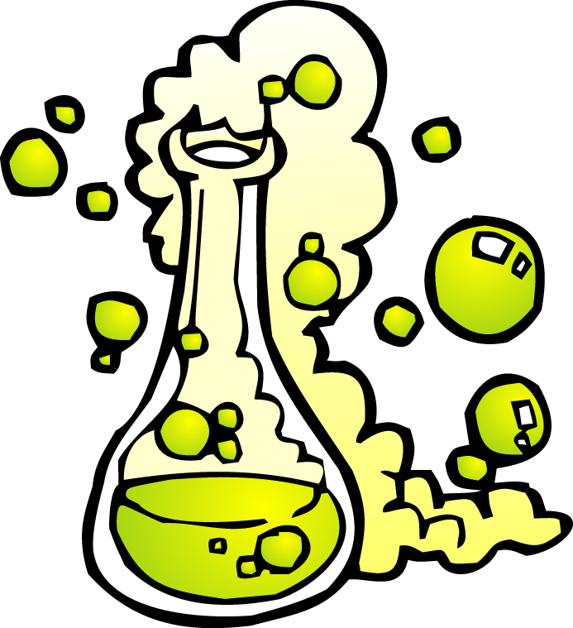We live in a world of change-rapid technological changes, severe weather changes, and predictable physical changes. Within our bodies, we depend on complex chemical changes to breathe, to see, to move, indeed to grow. What is a chemical change? How can we identify a chemical change? What kinds of evidence can we gather to determine that a chemical change has indeed occurred, whether in nature or in the laboratory?

**Concepts**

* + - Chemical change • Chemical reaction
    - Chemical properties

**Background**

A chemical change is defined as a change in the composition and properties of a substance. The transformation of old materials (reactants) into new substances (products) as a result of a chemical change is called a *chemical reaction.* Both in the natural world and in the labora­tory we recognize that a chemical reaction has occurred by observing the appearance of products with physical and chemical properties different from the reactants from which they were made.

There are many types of observable changes that are used to identify that a chemical reac­tion has occurred. Signs of chemical change include:

* formation of a solid *precipitate* upon mixing of two solutions
* release of *gas* bubbles that are not due to a physical change (boiling or sublimation)
* a *color change* that does not result from dilution or color mixing
* a *temperature change* that is not caused by external heating or cooling

These signs of change illustrate the dynamic nature of chemical reactions. What they do not reveal, however, is where the real action is taking place-at the level of atoms and mole­cules. Chemical reactions arise due to the rearrangement of atoms and molecules. Compounds are formed when atoms combine to form molecules. When the forces or bonds linking atoms together within molecules break, compounds can also decompose to reform their constituent elements. Molecules of one compound can exchange atoms or groups of atoms with other elements or compounds, generating new substances.

We cannot see these rearrangements at the atomic level. What evidence do we have for them? The *law of conservation of mass* states that in any physical or chemical reaction, mass is neither created nor destroyed-it is conserved. This implies that atoms are not gained or lost in a chemical reaction, they are only rearranged.

**Experiment Overview**

The purpose of this experiment is to examine the chemical properties of hydrochloric acid

and copper chloride, to identify the types of reactions that they undergo, and to determine

if the law of conservation of mass applies to a sample chemical reaction in one of these series.

**Pre-Lab Questions**

1. Which of the following everyday processes represent chemical changes: a nail rusts, ice melts, wood burns, a banana ripens, and sugar dissolves in water?
2. Milk stored beyond its expiration date eventually turns sour. This is an example of a chemical change. What signs of chemical change are observed when milk sours?

**Part A. Reactions of *Hydrochloric* Acid**

*Record all observations in Data Table A.*

1. Add 20drops of *hydrochloric acid* to each well, A1-A6. Record the color and appearance of the hydrochloric acid solution. Record data below
2. Measure and record the initial temperature of the solution in well AI. *Note:* Assume that all solutions in wells AI-A6 are at the same initial temperature. Record data below
3. Dip a piece of blue litmus paper in A1 (hydrochloric acid) Record data below.
4. Add 20 drops of *sodium hydroxide* solution to A1. Immediately place the thermometer back in the well and record any temperature change. After one minute, test the solution again with a fresh piece of blue litmus paper. Record All observations in the reaction well #1 section of the data table.
5. To well A2, add a small amount of solid *sodium bicarbonate.* Observe and record all changes, including the temperature. Once any initial evidence for reaction has subsided, continue adding sodium bicarbonate in small amounts until a total of three portions have been added. Record All observations in the reaction well #2 section of the data table.
6. Use a new, clean pipet to add 20 drops of *silver nitrate* solution to well *A3.* Record All observations in the reaction well #3 section of the data table.
7. Use forceps to add one small piece of *mossy zinc* to well A4. Record All observations in the reaction well #4 section of the data table.
8. Use forceps to add one small piece of *aluminum shot* to well A5. Record All observations in the reaction well #5 section of the data table.
9. To well A6, add one small piece of *magnesium ribbon.* Record All observations in the reaction well #6 section of the data table.
10. Using forceps, remove any pieces of unreacted metal from wells A4-A6. Rinse the metals with water and dispose of them according to your teacher's instructions.
11. Clean the well plate in the sink with water

**Data Table A: Reactions with Hydrochloric Acid, HCl**

**What does the HCl look like inititally?**

* **Color and appearance:**
* **Temperature:**
* **Litmus Paper results:**

**PART A DATA:**

|  |  |  |
| --- | --- | --- |
| **Reaction Well** | **Reactants** | **Observations** |
| 1 | HCl + NaOH |  |
| 2 | HCl + NaHCO3 |  |
| 3 | HCl + AgNO3 |  |
| 4 | HCl + Zn |  |
| 5 | HCl + Al |  |
| 6 | HCl + Mg |  |

**Part B. Reactions of *Cupric Chloride***

1. Add 20 drops of *cupric chloride* to each well, BI-B6. Record the color and appearance of the solution and measure its initial temperature in one of the wells.
2. Use forceps to add one small piece of *aluminum shot* to well B1. Record all observations, including the temperature in the Reaction Well 1 Section.
3. Use forceps to add one small piece of *mossy zinc* to well B2. Record all observations in the Reaction Well 2 Section.
4. Add 20 drops of *ammonium hydroxide* solution to well B3. Record all observations in the Reaction Well 3 Section.
5. Add 20 drops of *sodium carbonate* solution to well B4. Record all observations in the Reaction Well 4 Section.
6. Add 20 drops of *silver nitrate* solution to well B5. Record all observations in the Reaction Well 5 Section.
7. Using forceps, remove any pieces of unreacted metal from wells B1-B2..
8. After noting any changes in the final appearance of the mixtures in wells B1-B5, wash the contents of the reaction plate down the drain with a large amount of excess water.

**Data Table B: Reactions with Copper Chloride, CuCl2**

**What does the CuCl2 look like initially?**

* **Color and appearance:**
* **Temperature:**

|  |  |  |
| --- | --- | --- |
| **Reaction Well** | **Reactants** | **Observations** |
| 1 | CuCl2 + Al (shot) |  |
| 2 | CuCl2 + Zn |  |
| 3 | CuCl2 + NH4OH |  |
| 4 | CuCl2 + Na2CO3 |  |
| 5 | CuCl2 + AgNO3 |  |

**Post-Lab Questions**

1. *Summarize* the observations of chemical change in the reactions of HCl and CuCl2, respectively. All reactions should be listed; some reactions may appear more than once.

|  |  |  |
| --- | --- | --- |
| **Signs of a Chemical Reaction** | **Reactions of HCl (part a)** | **Reactions of CuCl2 (part b)** |
| **Precipitate** |  |  |
| **Gas Bubbles** |  |  |
| **Color Change** |  |  |
| **Temperature Change** |  |  |
| **No Observable Change** |  |  |

1. Compare and contrast the reactions of Al, Mg, and Zn with HCl.
2. Based on the observed reactions of HCI and CuCl2 with different metals, predict whether CuCl2 will react with Mg. Use evidence from your observations to support your answer.
3. What is the purpose of this lab? On the back of this page, describe what you did in this lab to meet that purpose. Your answer should be at least four sentences. Refer to the background information to help you answer.